Table of Contents
Week 1-2: Database Design and Schema Creation 3
RESULT: 8
Week 3: Storage Management – Part 1 9
PROOF: 9
Week 4: Storage Management – Part 2 13
PROOF: 15
EXAMPLE: 16
Week 5: Indexing and Query Optimization 17
INDEXING: 17
Week 6: Memory Management 23
BUFFER POOL: 23
CONFIGURE PLAN CACHE: 24
Week 7: Transactions and Concurrency Control 36
Transaction 1: Borrow a Book 37
Transaction 2: Return a Book 39
Transaction 3: Reserve a Book 41
Transaction 4: Add a New Book to the Library 43
Transaction 5: Delete a User Account 44
Week 8: Security and Backup 46
Week 9: Advanced Features 49
TRIGGERS: 49
PROOF: 50
PROOF: 51
COMPLEX QUERIES: 52
-EXAMPLE 1: 52
-EXAMPLE 2: 53

Week 1-2: Database Design and Schema Creation

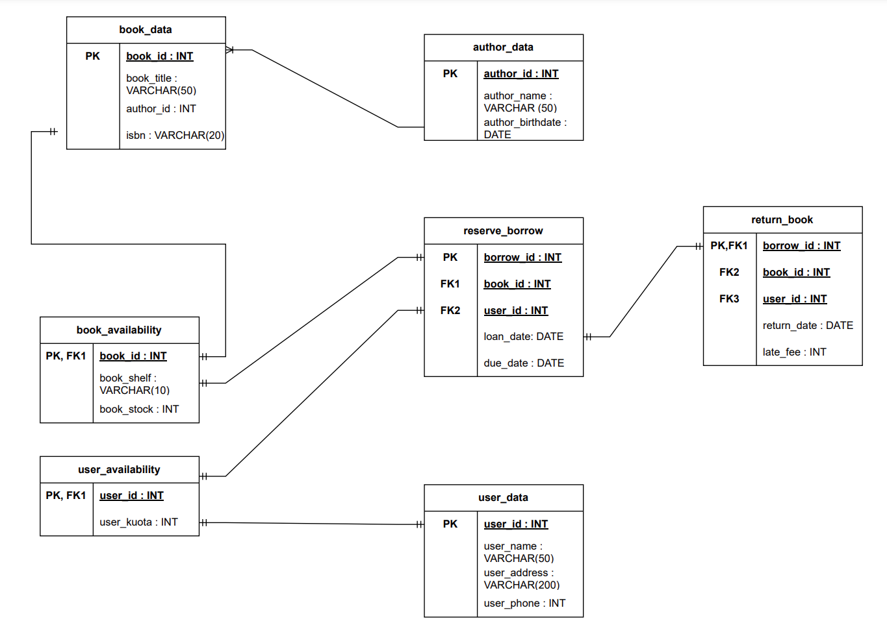
https://drive.google.com/file/d/1TUd8XUODX_ADhCNoXPZyA_Q_c-06eyGT/view?usp=sharing

From the data given, there are 3 tables that is a must. Which are: author_data, user_data, and book_data. The rest are there to make things go smoothly.

In author_data I set an author_id as its primary key, to make it easier to identify them. Then, the table consists of author_name and author_birthdate.

In user_data I as well set an user_id as its primary key, to make it easier to identify them. Then, the table consists of user_name and user_address.

In book_data I again set an book_id as its primary key, to make it easier to identify them. Then, the table consists of book_title, isbn, and author_id as a foreign key to identify the book’s author.

Next is the book_availability table, I made this because if it were immediately the reserve_borrow table, book_data and reserve_borrow would have a many to many relationship, which makes them weak entities. Making an availability table solves that.
In availability I used book_id primary key. Then I added book_shelf to locate where the book is. I added book_stock to check if the book that the user wants to borrow is in stock. If the user_kuota is >0 and the book_stock is also >0, then we would proceed to the reserve_borrow table and when a user wants to borrow the book, we will update book_stock by -1.

Then there is the user_availability table, I used user_id primary key. Then I added user_kuota to check if the user kuota to borrow books. If the user_kuota is >0 and the then we would proceed to the reserve_borrow table and when a user wants to borrow the book, we will update user_kuota by -1.

Next is the reserve_borrow table, after book_availability and user_availability table, this would be the table to proceed to. I set borrow_id as a primary key, as it will be unique. So that it wouldn’t be confusing if the same user were to borrow the same book multiple times. Then there is the loan_date and due_date.

Lastly is the return_table. I used borrow_id as a primary key, not adding a new key as borrow_id will already be unique on its own. I also added book_id and user_id to know what book was returned and which user returned it. Then I added the return_date to check if the book is late or not based on the set due_date in the reserve_borrow table. Then I also added late_fee if the book is returned past the due_date.

book_data and author_data has a relationship of one to many, because a book can have one author but authors can have more than one book.

book_data and book_availability has a relationship of one to one, because a book can have one book_availability, and availability can have only one book_data at once.

user_data and user_availability has a relationship of one to one, because a user can have one user_availability at a time, and user_availability can’t have more than one user_data at once.

book_availability and reserve_borrow has a relationship of one to one, because one availability can have one reserve_borrow at a time, and reserve_borrow can’t have more than one book_availability at once.

user_availability and reserve_borrow has a relationship of one to one, because one availability can have one reserve_borrow at a time, and reserve_borrow can’t have more than one user_availability at once.

Lastly, reserve_borrow and return_book has a relationship of one to one, because one reserve_borrow can have one return_book at a time, and return_book can’t have more than one reserve_borrow at once.

INITIAL SQL CODE
CREATE TABLE book_data(
book_id INT NOT NULL,
book_title VARCHAR(50) NOT NULL,
isbn VARCHAR(20) NOT NULL,
author_id INT,
PRIMARY KEY(book_id)
);

CREATE TABLE author_data(
author_id INT NOT NULL,
author_name VARCHAR(50) NOT NULL,
author_birthdate DATE NOT NULL,
PRIMARY KEY(author_id)
);

ALTER TABLE book_data
ADD FOREIGN KEY(author_id)
REFERENCES author_data(author_id)
ON DELETE SET NULL;

CREATE TABLE user_data(
user_id INT NOT NULL,
user_name VARCHAR(50) NOT NULL,
user_address VARCHAR(200) NOT NULL,
user_phone INT NOT NULL,
PRIMARY KEY(user_id)
);

CREATE TABLE book_availability(
book_id INT NOT NULL,
book_stock INT NOT NULL,
book_shelf VARCHAR(10) NOT NULL,
FOREIGN KEY(book_id) REFERENCES book_data(book_id) ON DELETE CASCADE,
PRIMARY KEY(book_id)
);

CREATE TABLE user_availability(
user_id INT NOT NULL,
user_kuota INT NOT NULL,
FOREIGN KEY(user_id) REFERENCES user_data(user_id) ON DELETE CASCADE,
PRIMARY KEY(user_id)
);

CREATE TABLE reserve_borrow(
borrow_id INT ,
book_id INT,
user_id INT,
loan_date DATE NOT NULL,
due_date DATE NOT NULL,
FOREIGN KEY(user_id) REFERENCES user_data(user_id) ON DELETE CASCADE,
FOREIGN KEY(book_id) REFERENCES book_data(book_id) ON DELETE SET NULL,
PRIMARY KEY(borrow_id)
);

CREATE TABLE return_book(
borrow_id INT,
book_id INT,
user_id INT,
return_date DATE NOT NULL,
late_fee INT,
FOREIGN KEY(user_id) REFERENCES user_data(user_id) ON DELETE CASCADE,
FOREIGN KEY(book_id) REFERENCES book_data(book_id) ON DELETE SET NULL,
FOREIGN KEY(borrow_id) REFERENCES reserve_borrow(borrow_id) ON DELETE NO ACTION,
PRIMARY KEY(borrow_id)
);

RESULT:
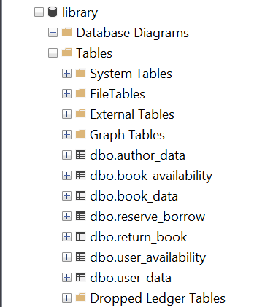

Week 3: Storage Management – Part 1

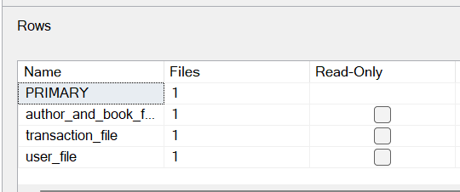
Based on my erd and code, I have decided to make 3 filegroups: author_and _book_file, (to store author_data and book_data), user_file (to store user_data), and transaction_file (to store user_availability, book_availability, reserve_borrow, and return_book).

PROOF:
-author_data
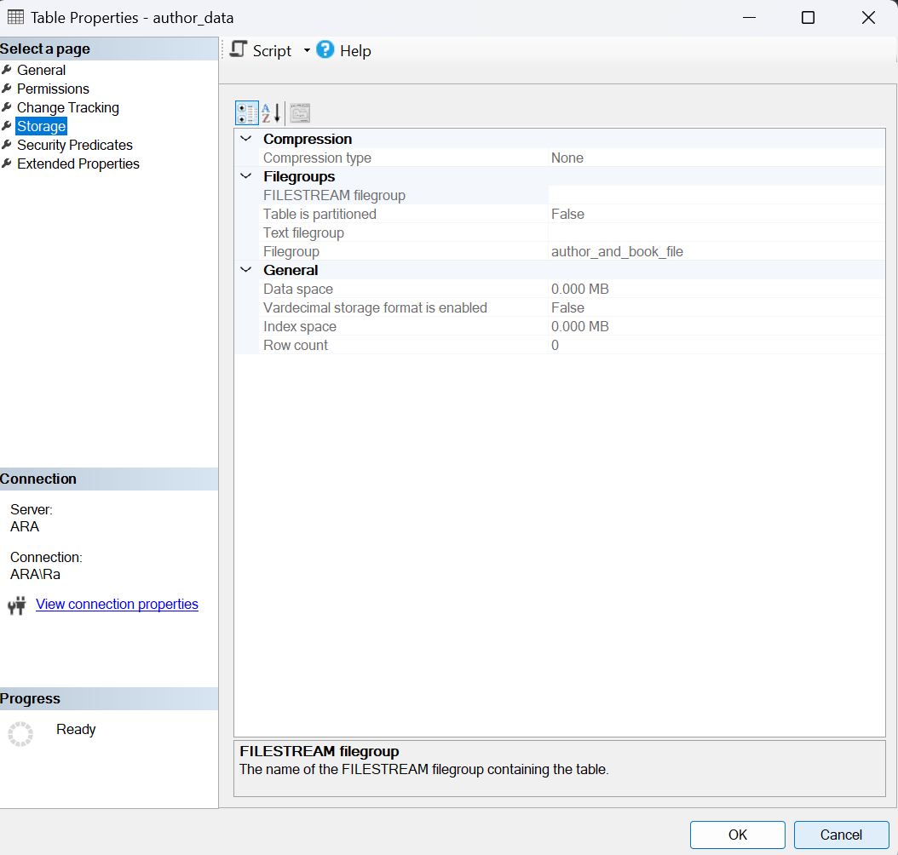

-book_data
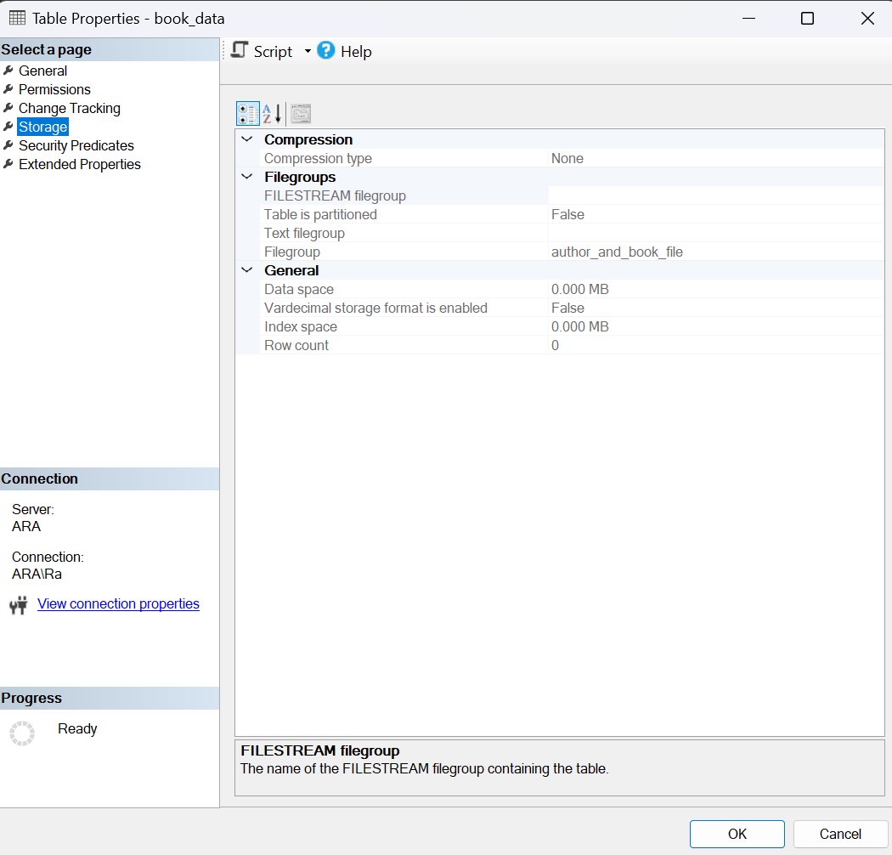

-user_data
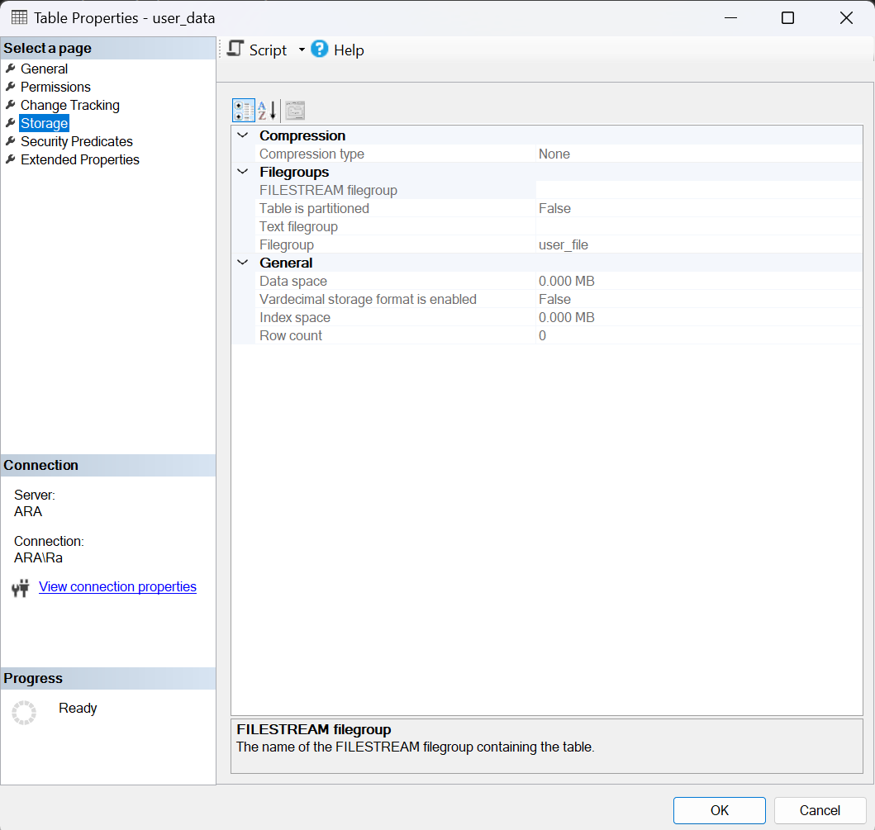

-user_availability
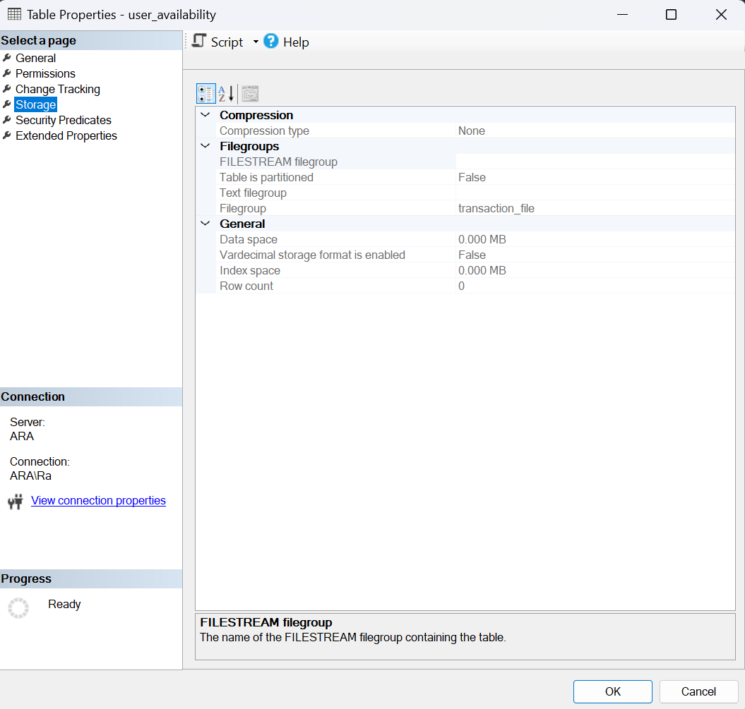

-book_availability
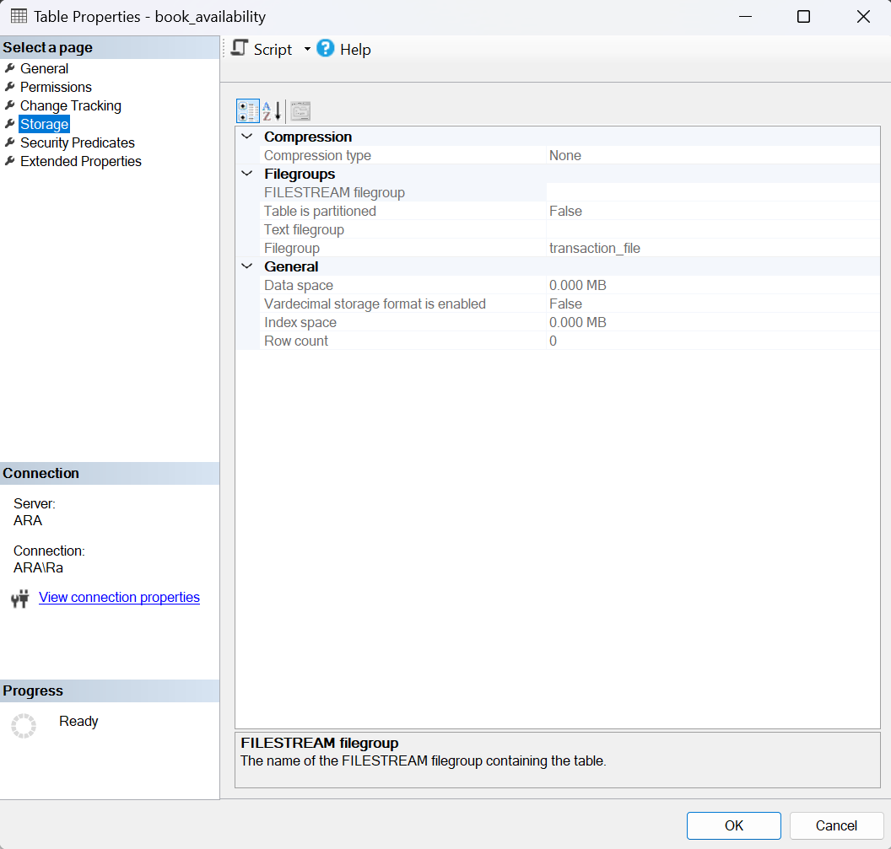
-reserve_borrow
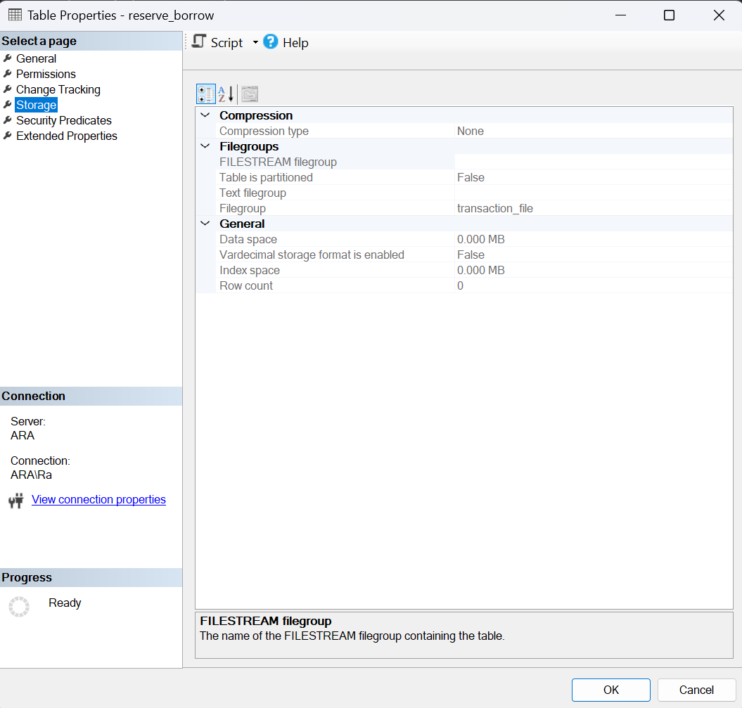

-return_book
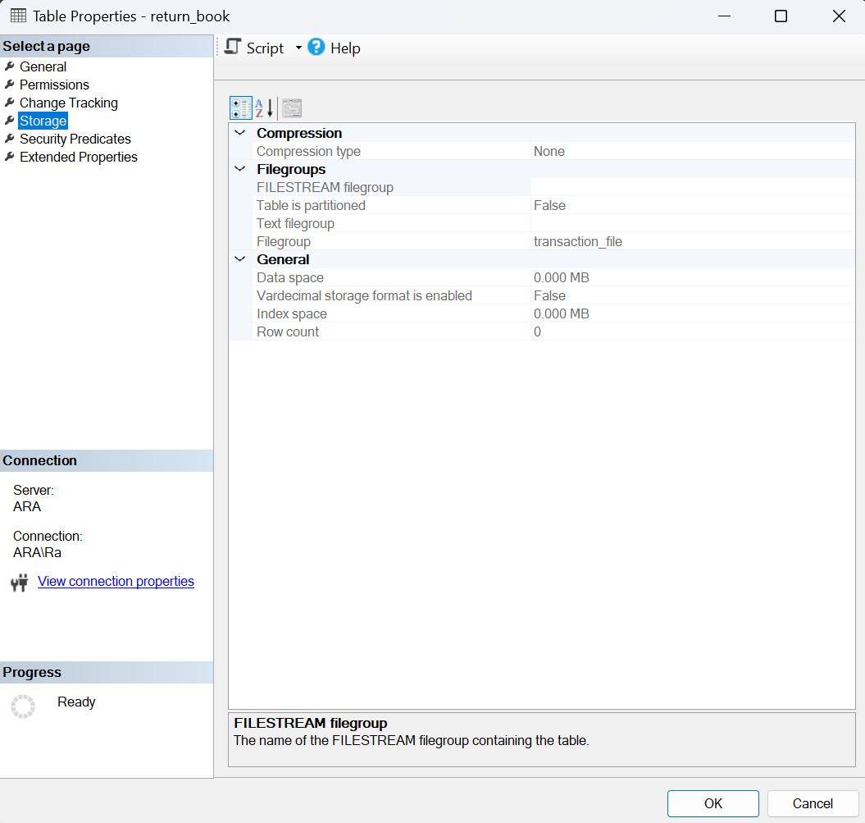

Week 4: Storage Management – Part 2
USE [library]
GO

CREATE PARTITION FUNCTION yearly_borrowing_partition (DATE)
AS RANGE LEFT FOR VALUES ('2022-01-01', '2023-01-01', '2024-01-01');

CREATE PARTITION SCHEME yearly_borrowing_scheme
AS PARTITION yearly_borrowing_partition
TO (borrowing_before_2022, borrowing_in_2022, borrowing_in_2023, borrowing_after_2023);

BEGIN TRANSACTION
ALTER TABLE [dbo].[return_book] DROP CONSTRAINT [FK__return_bo__borro__66603565]

ALTER TABLE [dbo].[reserve_borrow] DROP CONSTRAINT [PK__reserve___262B57A05EC329DB] WITH ( ONLINE = OFF )

ALTER TABLE [dbo].[reserve_borrow] ADD PRIMARY KEY NONCLUSTERED
(
[borrow_id] ASC
)WITH (PAD_INDEX = OFF, STATISTICS_NORECOMPUTE = OFF, SORT_IN_TEMPDB = OFF, IGNORE_DUP_KEY = OFF, ONLINE = OFF, ALLOW_ROW_LOCKS = ON, ALLOW_PAGE_LOCKS = ON, OPTIMIZE_FOR_SEQUENTIAL_KEY = OFF) ON [transaction_file]

CREATE CLUSTERED INDEX [ClusteredIndex_on_yearly_borrowing_scheme_638640246553947084] ON [dbo].[reserve_borrow]
(
[loan_date]
)WITH (SORT_IN_TEMPDB = OFF, DROP_EXISTING = OFF, ONLINE = OFF) ON [yearly_borrowing_scheme]([loan_date])

DROP INDEX [ClusteredIndex_on_yearly_borrowing_scheme_638640246553947084] ON [dbo].[reserve_borrow]

ALTER TABLE [dbo].[return_book] WITH CHECK ADD FOREIGN KEY([borrow_id])
REFERENCES [dbo].[reserve_borrow] ([borrow_id])

COMMIT TRANSACTION

I decided to make storage partition for the reserve_borrow table to partition them per year. I didn’t make any other partitions, as I didn’t think there was a need to for the other datas

PROOF:
-partition and partition scheme
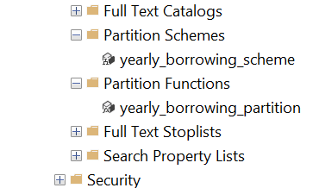

-partition success

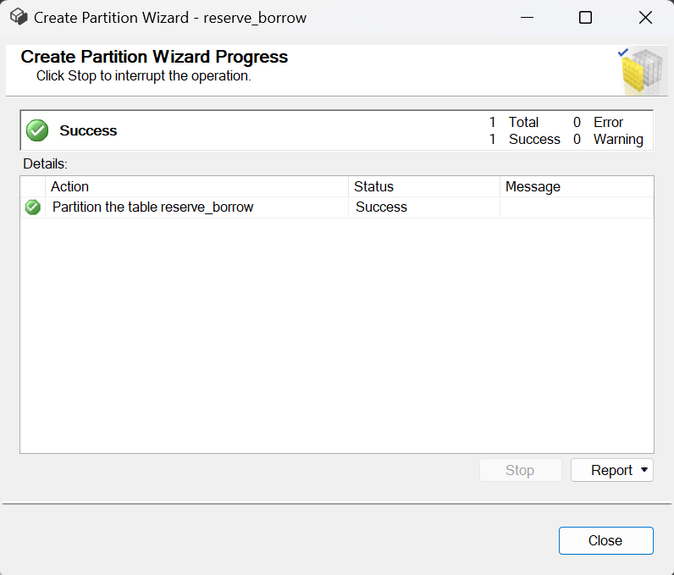

EXAMPLE:
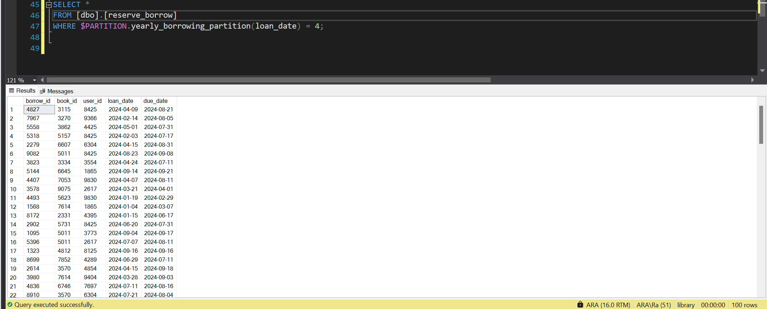
If I would like to access borrow data from 2024, I would enter the 4th partition, as the 4th partition holds borrow data from after 2023

Week 5: Indexing and Query Optimization

INDEXING:
-book_data table
CREATE TABLE book_data(
book_id INT NOT NULL,
book_title VARCHAR(50) NOT NULL,
isbn VARCHAR(20) NOT NULL,
author_id INT,
PRIMARY KEY(book_id)
);
In this table the primary key is book_id which is provided by the dataset, but if it weren’t I would randomize a number using the following c code, same as I will do for the other tables. Then we have book_title which is of course important as you can’t save a book in the database without knowing its title. After that we have isbn, we have to store this incase we need it, like for example, if a user wanted to know the isbn of the book to see its authenticity and such. Lastly, author_id to know who the author of the book is.

-c code to randomize numbers
#include <stdio.h>
#include <stdlib.h>
#include <time.h>

int main() {
srand(time(NULL));
int max = 10000, min = 1000;
for (int i = 0; i < 100; i++) {
printf("%d\n", rand() % (max - min) + min);
}
}
With the code above, it would generate 100 numbers with each number containing 4 digits.
-author_data table
CREATE TABLE author_data(
author_id INT NOT NULL,
author_name VARCHAR(50) NOT NULL,
author_birthdate DATE NOT NULL,
PRIMARY KEY(author_id)
);
As I said before, I used a random number generator to generate the ids, one of such is all of the author_ids that I have entered into the database. Then, we have the author_name which is stored incase we need it, for example if a user like a book and would like to read more from said author. Lastlt, we have the author’s birthdate, which is stored more as a formality.

-user_data table
CREATE TABLE user_data(
user_id INT NOT NULL,
user_name VARCHAR(50) NOT NULL,
user_address VARCHAR(200) NOT NULL,
user_phone INT NOT NULL,
PRIMARY KEY(user_id)
);
user_id was also provided, but again, I would use the c code, if it weren’t. then we have user_name, which is essential as if we were to store a user’s data we should at least know their name. Then we have user_address, which we need incase we were to send overdue fee bills to their home. Lastly, we have user_phone to contact them about overdue fees before mailing them to their house.

-book_availability table
CREATE TABLE book_availability(
book_id INT NOT NULL,
book_stock INT NOT NULL,
book_shelf VARCHAR(10) NOT NULL,
FOREIGN KEY(book_id) REFERENCES book_data(book_id) ON DELETE CASCADE,
PRIMARY KEY(book_id)
);
Here we have the book_availability table which uses book_id which is a foreign key from the book_data table as a primary key. Then we have the book_stock, to check if the book is available or not. Then lastly, we have the book_shelf to know where the book is stored.

-user_availability table
CREATE TABLE user_availability(
user_id INT NOT NULL,
user_kuota INT NOT NULL,
FOREIGN KEY(user_id) REFERENCES user_data(user_id) ON DELETE CASCADE,
PRIMARY KEY(user_id)
);

Here we have the user_availability table which uses user_id which is a foreign key from the user_data table as a primary key. Then lastly, we have the user_kuota which determines if the user is applicable to borrow more books.

-reserve_borrow table
CREATE TABLE reserve_borrow(
borrow_id INT ,
book_id INT,
user_id INT,
loan_date DATE NOT NULL,
due_date DATE NOT NULL,
FOREIGN KEY(user_id) REFERENCES user_data(user_id) ON DELETE CASCADE,
FOREIGN KEY(book_id) REFERENCES book_data(book_id) ON DELETE SET NULL,
PRIMARY KEY(borrow_id)
);

In this table I again generated a unique 4 digit number for each borrow_id using the c code. Then we have book_id which is a foreign key from the book_data table to know which book is being borrowed. After that, user_id which is a foreign key from the user_data table to know who is borrowing the book. Then we have loan_date as well as due_date, to know when to book is borrowed and when it should be returned.

-return_book table
CREATE TABLE return_book(
borrow_id INT,
book_id INT,
user_id INT,
return_date DATE NOT NULL,
late_fee INT,
FOREIGN KEY(user_id) REFERENCES user_data(user_id) ON DELETE CASCADE,
FOREIGN KEY(book_id) REFERENCES book_data(book_id) ON DELETE SET NULL,
FOREIGN KEY(borrow_id) REFERENCES reserve_borrow(borrow_id) ON DELETE NO ACTION,
PRIMARY KEY(borrow_id)
);

In this table, I used the borrow_id from the reserve_borrow table which is a foreign key, as a primary key of this table. Then again I put book_id which is a foreign key from the book_data table to know which book is being returned. After that, user_id which is a foreign key from the user_data table to know who is returning the book. Then we have the return_date to know when the book is being returned. Lastly, we have the late_fee, if the book is returned past the due date.
EXPLAIN:
As in ssms the function EXPLAIN, isn’t called explain, but called showplan, so I used that.

-user_availability table
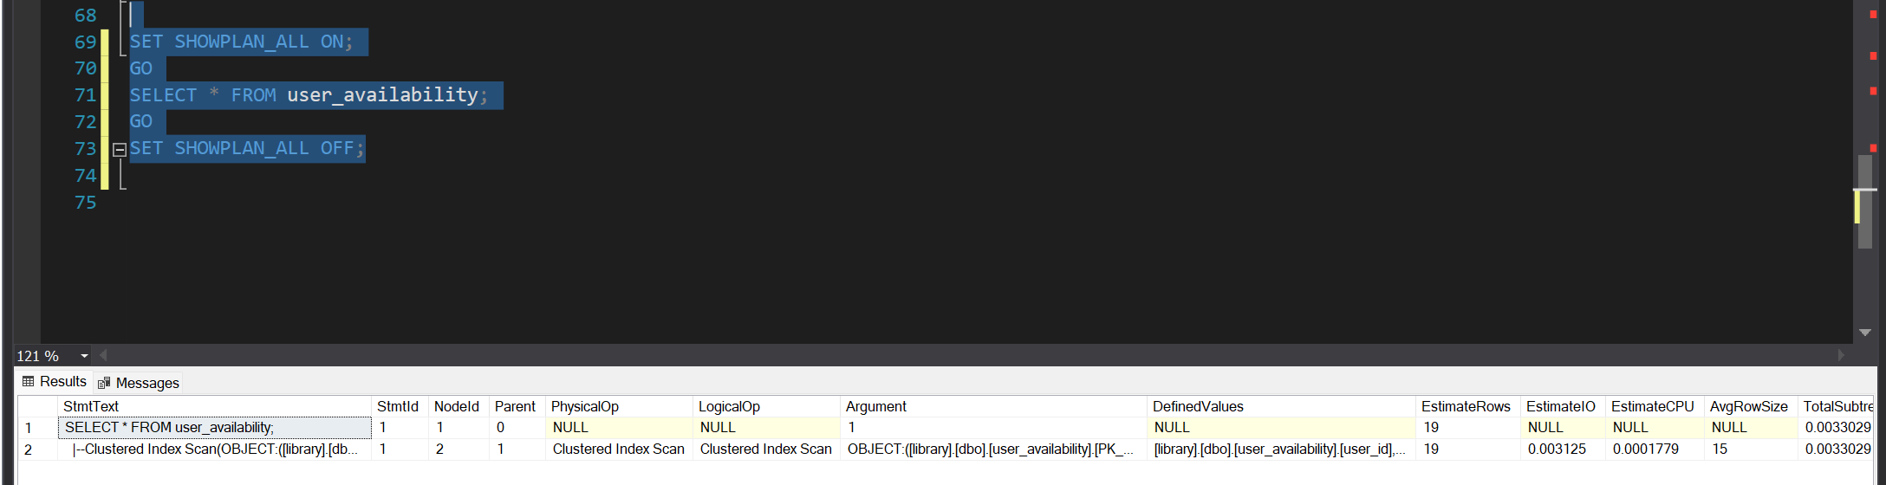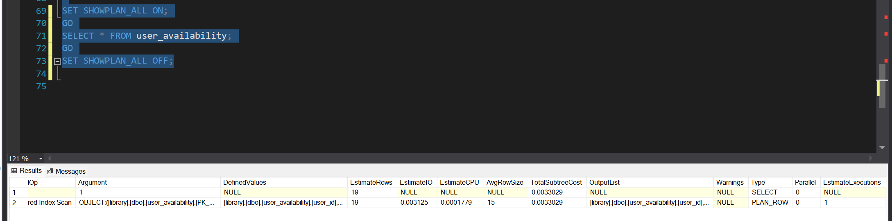

-book_availability table
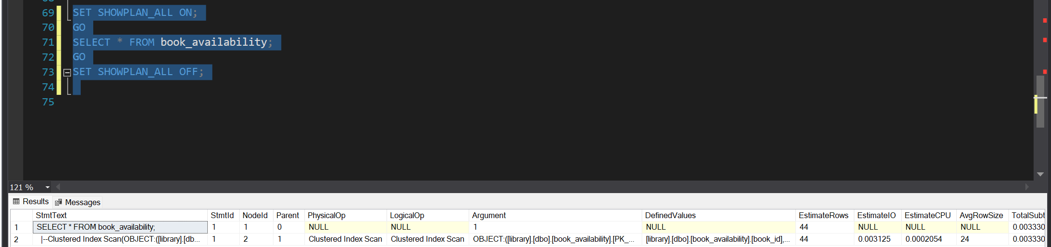
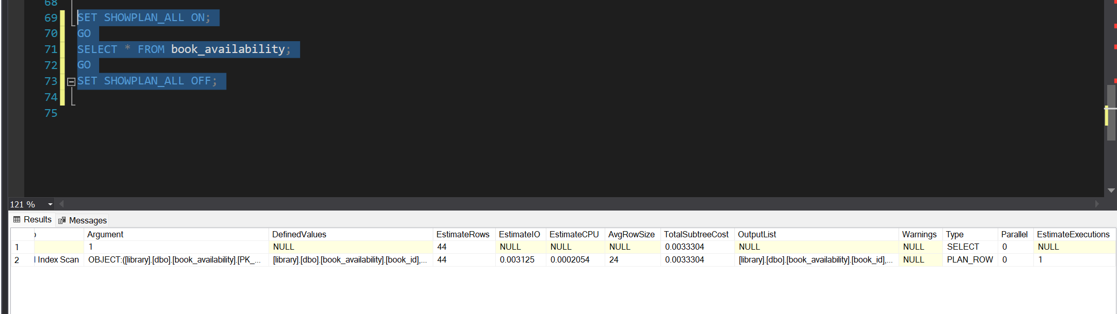
-reserve_borrow table
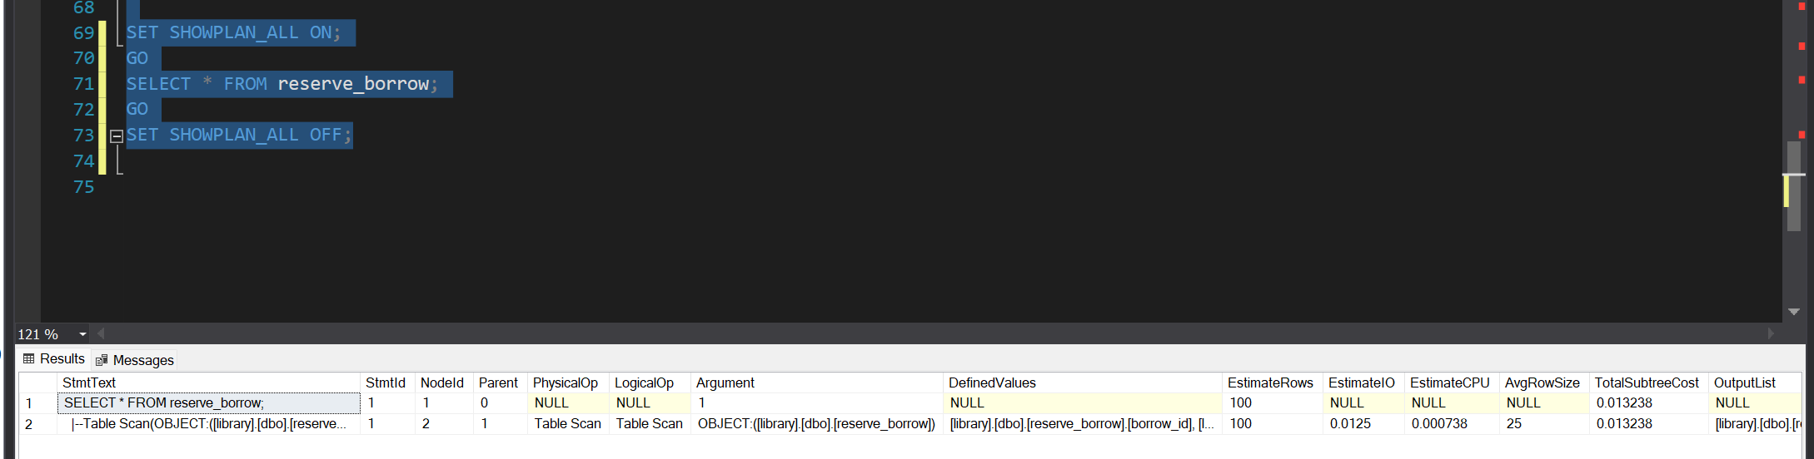
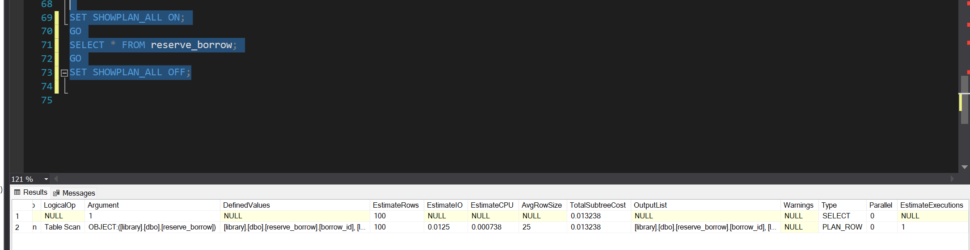

-return_book table
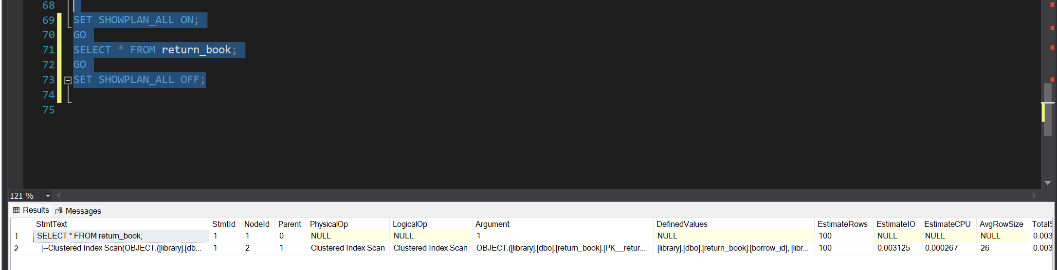
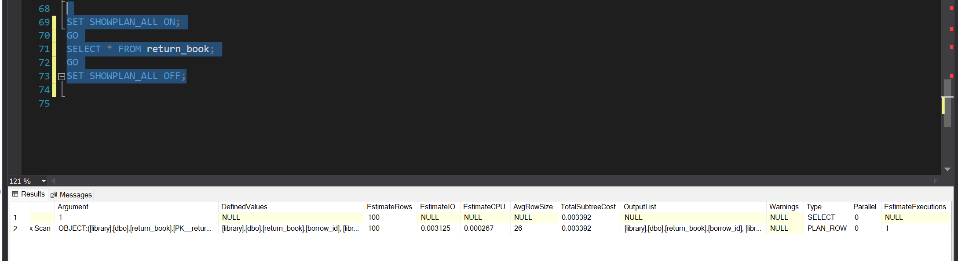

Week 6: Memory Management

BUFFER POOL:
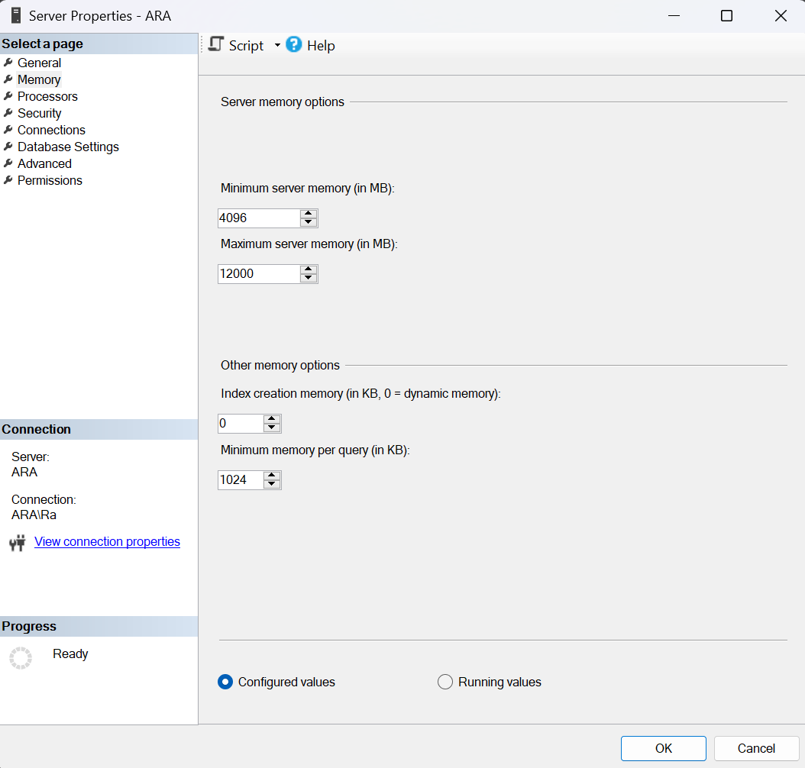
I chose to set the minimum memory as 4 GB for the SQL Server, this makes it so that it will always have enough memory to handle basic tasks and avoid slowdowns, even when the system memory is limited. This also prevents the server from running out of resources and makes sure that the SQL Server operates smoothly.

Then I chose to set the maximum memory of 12 GB on a server with 16 GB of RAM, this leaves 4 GB available for the operating system and other programs. This will help avoid performance issues caused by SQL Server using too much memory, which could slow down the system or make it unstable.

This setup makes sure that both the SQL Server and the system run smoothly.

CONFIGURE PLAN CACHE:
-plan cache usage
DBCC FREEPROCCACHE;

SELECT * FROM reserve_borrow;

SELECT
[object_name] AS [CounterName],
[cntr_value] AS [Value]
FROM
sys.dm_os_performance_counters
WHERE
[object_name] LIKE '%Plan Cache%'
AND [counter_name] = 'Cache Hit Ratio';
After freeing all the cache, then running the most likely to be the most frequent query, as well as running the code to monitor the plan cache usage, here are the results
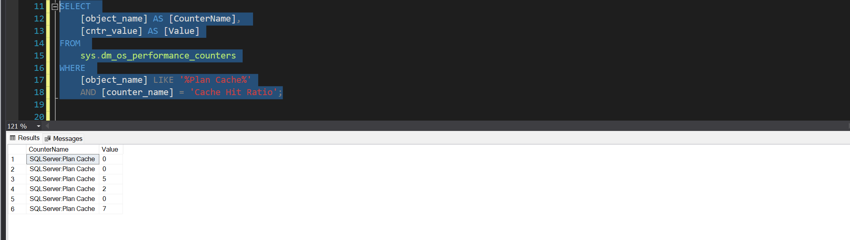

-identify frequently accessed data
SELECT TOP 10
query_stats.query_hash AS "Query Hash",
SUM(query_stats.execution_count) AS "Execution Count",
MIN(query_stats.creation_time) AS "Creation Time",
MAX(query_stats.last_execution_time) AS "Last Execution Time",
query_text.text AS "Query Text"
FROM sys.dm_exec_query_stats AS query_stats
CROSS APPLY sys.dm_exec_sql_text(query_stats.sql_handle) AS query_text
GROUP BY query_stats.query_hash, query_text.text
ORDER BY SUM(query_stats.execution_count) DESC;
After running the code above, we have now identified the most frequent queries, here are the results
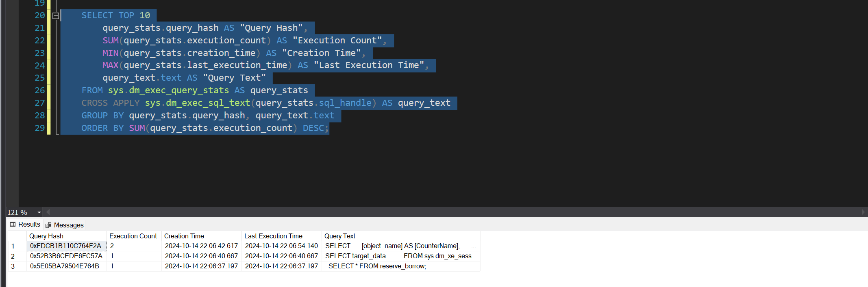

-Monitor and Adjust Memory Usage
SELECT
database_id,
file_id,
page_id,
page_level,
allocation_unit_id,
page_type,
COUNT(*) AS record_count
FROM sys.dm_os_buffer_descriptors
WHERE database_id = DB_ID('library')
GROUP BY
database_id,
file_id,
page_id,
page_level,
allocation_unit_id,
page_type;
After running the code above to monitor buffer pool usage, here are the results
They are too long to screenshot, so I just copy and pasted them, but here a screenshot for proof that I ran the code
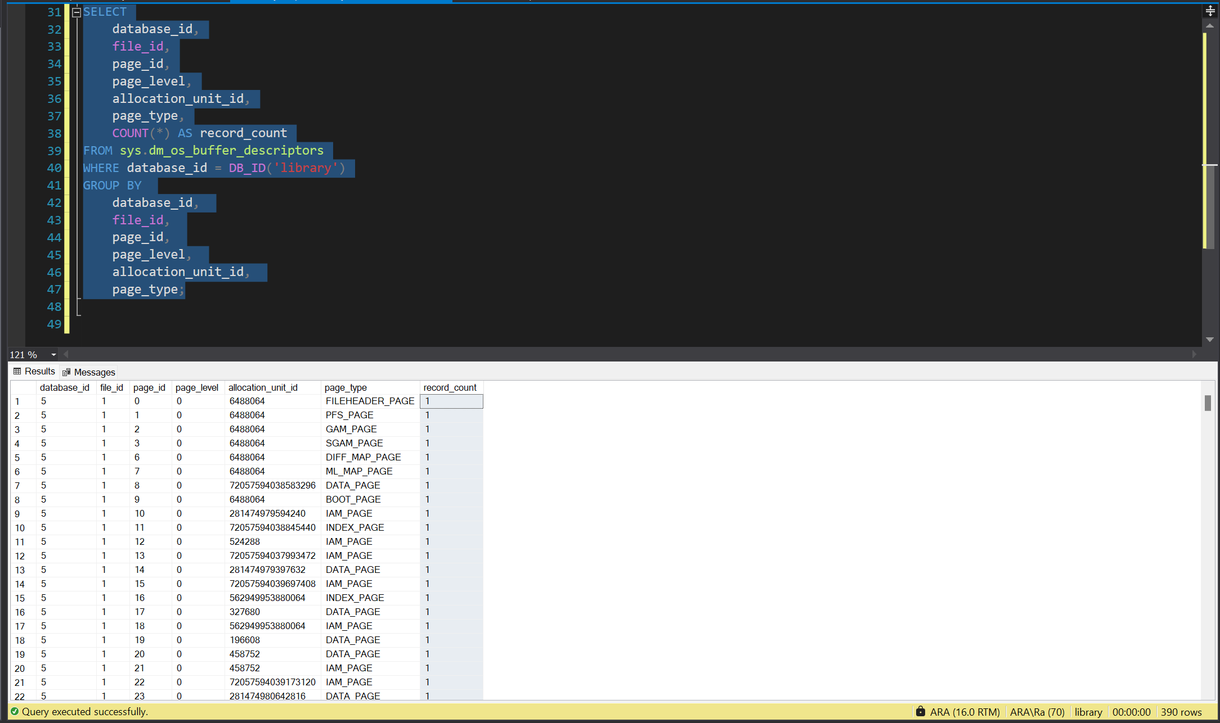
no | database_id | file_id, | page_id, | page_level, | allocation_unit_id, | page_type | record_count
1 | 5 | 1 | 0 | 0 | 6488064 | FILEHEADER_PAGE | 1
2 | 5 | 1 | 1 | 0 | 6488064 | PFS_PAGE | 1
3 | 5 | 1 | 2 | 0 | 6488064 | GAM_PAGE | 1
4 | 5 | 1 | 3 | 0 | 6488064 | SGAM_PAGE | 1
5 | 5 | 1 | 6 | 0 | 6488064 | DIFF_MAP_PAGE | 1
6 | 5 | 1 | 7 | 0 | 6488064 | ML_MAP_PAGE | 1
7 | 5 | 1 | 8 | 0 | 7.21E+16 | DATA_PAGE | 1
8 | 5 | 1 | 9 | 0 | 6488064 | BOOT_PAGE | 1
9 | 5 | 1 | 10 | 0 | 2.81E+14 | IAM_PAGE | 1
10 | 5 | 1 | 11 | 0 | 7.21E+16 | INDEX_PAGE | 1
11 | 5 | 1 | 12 | 0 | 524288 | IAM_PAGE | 1
12 | 5 | 1 | 13 | 0 | 7.21E+16 | IAM_PAGE | 1
13 | 5 | 1 | 14 | 0 | 2.81E+14 | DATA_PAGE | 1
14 | 5 | 1 | 15 | 0 | 7.21E+16 | IAM_PAGE | 1
15 | 5 | 1 | 16 | 0 | 5.63E+14 | INDEX_PAGE | 1
16 | 5 | 1 | 17 | 0 | 327680 | DATA_PAGE | 1
17 | 5 | 1 | 18 | 0 | 5.63E+14 | IAM_PAGE | 1
18 | 5 | 1 | 19 | 0 | 196608 | DATA_PAGE | 1
19 | 5 | 1 | 20 | 0 | 458752 | DATA_PAGE | 1
20 | 5 | 1 | 21 | 0 | 458752 | IAM_PAGE | 1
21 | 5 | 1 | 22 | 0 | 7.21E+16 | IAM_PAGE | 1
22 | 5 | 1 | 23 | 0 | 2.81E+14 | DATA_PAGE | 1
23 | 5 | 1 | 24 | 0 | 2.81E+14 | DATA_PAGE | 1
24 | 5 | 1 | 25 | 0 | 2.81E+14 | DATA_PAGE | 1
25 | 5 | 1 | 26 | 0 | 2.81E+14 | DATA_PAGE | 1
26 | 5 | 1 | 27 | 0 | 2.81E+14 | DATA_PAGE | 1
27 | 5 | 1 | 28 | 0 | 2.81E+14 | DATA_PAGE | 1
28 | 5 | 1 | 29 | 0 | 2.81E+14 | DATA_PAGE | 1
29 | 5 | 1 | 30 | 0 | 2.81E+14 | DATA_PAGE | 1
30 | 5 | 1 | 31 | 0 | 2.81E+14 | DATA_PAGE | 1
31 | 5 | 1 | 40 | 0 | 7.21E+16 | INDEX_PAGE | 1
32 | 5 | 1 | 41 | 0 | 7.21E+16 | IAM_PAGE | 1
33 | 5 | 1 | 42 | 0 | 7.21E+16 | DATA_PAGE | 1
34 | 5 | 1 | 43 | 0 | 2.81E+14 | INDEX_PAGE | 1
35 | 5 | 1 | 44 | 0 | 2.81E+14 | DATA_PAGE | 1
36 | 5 | 1 | 45 | 0 | 7.18E+16 | IAM_PAGE | 1
37 | 5 | 1 | 46 | 0 | 196608 | DATA_PAGE | 1
38 | 5 | 1 | 47 | 0 | 2.81E+14 | DATA_PAGE | 1
39 | 5 | 1 | 48 | 0 | 7.21E+16 | DATA_PAGE | 1
40 | 5 | 1 | 49 | 0 | 7.21E+16 | IAM_PAGE | 1
41 | 5 | 1 | 50 | 0 | 2.81E+14 | DATA_PAGE | 1
42 | 5 | 1 | 51 | 0 | 196608 | DATA_PAGE | 1
43 | 5 | 1 | 52 | 0 | 5.63E+14 | INDEX_PAGE | 1
44 | 5 | 1 | 53 | 0 | 2.81E+14 | DATA_PAGE | 1
45 | 5 | 1 | 54 | 0 | 2.81E+14 | DATA_PAGE | 1
46 | 5 | 1 | 55 | 0 | 5.63E+14 | IAM_PAGE | 1
47 | 5 | 1 | 56 | 0 | 2.81E+14 | DATA_PAGE | 1
48 | 5 | 1 | 57 | 0 | 2.81E+14 | DATA_PAGE | 1
49 | 5 | 1 | 58 | 0 | 2.81E+14 | DATA_PAGE | 1
50 | 5 | 1 | 59 | 0 | 2.81E+14 | DATA_PAGE | 1
51 | 5 | 1 | 60 | 0 | 2.81E+14 | DATA_PAGE | 1
52 | 5 | 1 | 61 | 0 | 2.81E+14 | DATA_PAGE | 1
53 | 5 | 1 | 62 | 0 | 2.81E+14 | DATA_PAGE | 1
54 | 5 | 1 | 63 | 0 | 2.81E+14 | DATA_PAGE | 1
55 | 5 | 1 | 64 | 0 | 196608 | DATA_PAGE | 1
56 | 5 | 1 | 65 | 0 | 196608 | DATA_PAGE | 1
57 | 5 | 1 | 66 | 0 | 196608 | DATA_PAGE | 1
58 | 5 | 1 | 67 | 0 | 196608 | DATA_PAGE | 1
59 | 5 | 1 | 68 | 0 | 196608 | DATA_PAGE | 1
60 | 5 | 1 | 69 | 0 | 196608 | DATA_PAGE | 1
61 | 5 | 1 | 70 | 0 | 196608 | DATA_PAGE | 1
62 | 5 | 1 | 71 | 0 | 196608 | DATA_PAGE | 1
63 | 5 | 1 | 72 | 0 | 7.21E+16 | INDEX_PAGE | 1
64 | 5 | 1 | 73 | 0 | 5.63E+14 | IAM_PAGE | 1
65 | 5 | 1 | 74 | 0 | 7.21E+16 | DATA_PAGE | 1
66 | 5 | 1 | 75 | 0 | 2.81E+14 | DATA_PAGE | 1
67 | 5 | 1 | 76 | 0 | 2.81E+14 | IAM_PAGE | 1
68 | 5 | 1 | 77 | 0 | 5.63E+14 | INDEX_PAGE | 1
69 | 5 | 1 | 78 | 0 | 5.63E+14 | IAM_PAGE | 1
70 | 5 | 1 | 79 | 0 | 8.44E+14 | INDEX_PAGE | 1
71 | 5 | 1 | 80 | 0 | 8.44E+14 | IAM_PAGE | 1
72 | 5 | 1 | 81 | 0 | 7.21E+16 | IAM_PAGE | 1
73 | 5 | 1 | 82 | 0 | 7.21E+16 | DATA_PAGE | 1
74 | 5 | 1 | 83 | 0 | 7.21E+16 | IAM_PAGE | 1
75 | 5 | 1 | 84 | 0 | 7.21E+16 | IAM_PAGE | 1
76 | 5 | 1 | 85 | 0 | 196608 | DATA_PAGE | 1
77 | 5 | 1 | 86 | 0 | 196608 | DATA_PAGE | 1
78 | 5 | 1 | 87 | 0 | 2.81E+14 | DATA_PAGE | 1
79 | 5 | 1 | 88 | 0 | 2.81E+14 | IAM_PAGE | 1
80 | 5 | 1 | 89 | 0 | 5.63E+14 | INDEX_PAGE | 1
81 | 5 | 1 | 90 | 0 | 5.63E+14 | IAM_PAGE | 1
82 | 5 | 1 | 91 | 0 | 2.81E+14 | DATA_PAGE | 1
83 | 5 | 1 | 92 | 0 | 2.81E+14 | IAM_PAGE | 1
84 | 5 | 1 | 93 | 0 | 5.63E+14 | INDEX_PAGE | 1
85 | 5 | 1 | 94 | 0 | 5.63E+14 | IAM_PAGE | 1
86 | 5 | 1 | 95 | 0 | 8.44E+14 | INDEX_PAGE | 1
87 | 5 | 1 | 96 | 0 | 8.44E+14 | IAM_PAGE | 1
88 | 5 | 1 | 97 | 0 | 2.81E+14 | DATA_PAGE | 1
89 | 5 | 1 | 98 | 0 | 2.81E+14 | IAM_PAGE | 1
90 | 5 | 1 | 99 | 0 | 5.63E+14 | INDEX_PAGE | 1
91 | 5 | 1 | 100 | 0 | 5.63E+14 | IAM_PAGE | 1
92 | 5 | 1 | 101 | 0 | 2.81E+14 | DATA_PAGE | 1
93 | 5 | 1 | 102 | 0 | 2.81E+14 | IAM_PAGE | 1
94 | 5 | 1 | 103 | 0 | 2.81E+14 | DATA_PAGE | 1
95 | 5 | 1 | 104 | 0 | 2.81E+14 | IAM_PAGE | 1
96 | 5 | 1 | 105 | 0 | 5.63E+14 | INDEX_PAGE | 1
97 | 5 | 1 | 106 | 0 | 5.63E+14 | IAM_PAGE | 1
98 | 5 | 1 | 107 | 0 | 2.81E+14 | DATA_PAGE | 1
99 | 5 | 1 | 108 | 0 | 2.81E+14 | IAM_PAGE | 1
100 | 5 | 1 | 109 | 0 | 196608 | DATA_PAGE | 1
101 | 5 | 1 | 110 | 0 | 7.21E+16 | DATA_PAGE | 1
102 | 5 | 1 | 111 | 0 | 2.81E+14 | INDEX_PAGE | 1
103 | 5 | 1 | 112 | 0 | 2.81E+14 | DATA_PAGE | 1
104 | 5 | 1 | 113 | 0 | 2.81E+14 | DATA_PAGE | 1
105 | 5 | 1 | 114 | 0 | 7.21E+16 | IAM_PAGE | 1
106 | 5 | 1 | 115 | 0 | 7.21E+16 | INDEX_PAGE | 1
107 | 5 | 1 | 116 | 0 | 2.81E+14 | DATA_PAGE | 1
108 | 5 | 1 | 117 | 0 | 2.81E+14 | IAM_PAGE | 1
109 | 5 | 1 | 118 | 0 | 5.63E+14 | INDEX_PAGE | 1
110 | 5 | 1 | 119 | 0 | 5.63E+14 | IAM_PAGE | 1
111 | 5 | 1 | 120 | 0 | 8.44E+14 | INDEX_PAGE | 1
112 | 5 | 1 | 121 | 0 | 8.44E+14 | IAM_PAGE | 1
113 | 5 | 1 | 122 | 0 | 1.13E+15 | INDEX_PAGE | 1
114 | 5 | 1 | 123 | 0 | 1.13E+15 | IAM_PAGE | 1
115 | 5 | 1 | 124 | 0 | 2.81E+14 | DATA_PAGE | 1
116 | 5 | 1 | 125 | 0 | 2.81E+14 | IAM_PAGE | 1
117 | 5 | 1 | 126 | 0 | 5.63E+14 | INDEX_PAGE | 1
118 | 5 | 1 | 127 | 0 | 5.63E+14 | IAM_PAGE | 1
119 | 5 | 1 | 128 | 0 | 2.81E+14 | DATA_PAGE | 1
120 | 5 | 1 | 129 | 0 | 2.81E+14 | IAM_PAGE | 1
121 | 5 | 1 | 130 | 0 | 7.21E+16 | IAM_PAGE | 1
122 | 5 | 1 | 131 | 0 | 327680 | IAM_PAGE | 1
123 | 5 | 1 | 132 | 0 | 2.81E+14 | DATA_PAGE | 1
124 | 5 | 1 | 133 | 0 | 2.81E+14 | DATA_PAGE | 1
125 | 5 | 1 | 134 | 0 | 7.21E+16 | IAM_PAGE | 1
126 | 5 | 1 | 135 | 0 | 2.81E+14 | DATA_PAGE | 1
127 | 5 | 1 | 136 | 0 | 7.21E+16 | INDEX_PAGE | 1
128 | 5 | 1 | 137 | 0 | 2.81E+14 | IAM_PAGE | 1
129 | 5 | 1 | 138 | 0 | 2.81E+14 | DATA_PAGE | 1
130 | 5 | 1 | 139 | 1 | 458752 | INDEX_PAGE | 1
131 | 5 | 1 | 140 | 0 | 2.81E+14 | DATA_PAGE | 1
132 | 5 | 1 | 141 | 0 | 2.81E+14 | IAM_PAGE | 1
133 | 5 | 1 | 142 | 0 | 5.63E+14 | INDEX_PAGE | 1
134 | 5 | 1 | 143 | 0 | 458752 | DATA_PAGE | 1
135 | 5 | 1 | 144 | 0 | 5.63E+14 | IAM_PAGE | 1
136 | 5 | 1 | 145 | 0 | 5.63E+14 | INDEX_PAGE | 1
137 | 5 | 1 | 146 | 1 | 5.63E+14 | INDEX_PAGE | 1
138 | 5 | 1 | 147 | 0 | 5.63E+14 | INDEX_PAGE | 1
139 | 5 | 1 | 148 | 0 | 2.81E+14 | INDEX_PAGE | 1
140 | 5 | 1 | 149 | 0 | 2.81E+14 | DATA_PAGE | 1
141 | 5 | 1 | 150 | 0 | 5.63E+14 | INDEX_PAGE | 1
142 | 5 | 1 | 151 | 0 | 2.81E+14 | DATA_PAGE | 1
143 | 5 | 1 | 152 | 0 | 2.81E+14 | IAM_PAGE | 1
144 | 5 | 1 | 153 | 0 | 2.81E+14 | DATA_PAGE | 1
145 | 5 | 1 | 154 | 0 | 2.81E+14 | IAM_PAGE | 1
146 | 5 | 1 | 155 | 0 | 2.81E+14 | DATA_PAGE | 1
147 | 5 | 1 | 156 | 0 | 5.63E+14 | INDEX_PAGE | 1
148 | 5 | 1 | 157 | 0 | 196608 | IAM_PAGE | 1
149 | 5 | 1 | 158 | 1 | 196608 | INDEX_PAGE | 1
150 | 5 | 1 | 159 | 0 | 196608 | DATA_PAGE | 1
151 | 5 | 1 | 160 | 1 | 327680 | INDEX_PAGE | 1
152 | 5 | 1 | 161 | 0 | 327680 | DATA_PAGE | 1
153 | 5 | 1 | 162 | 0 | 5.63E+14 | INDEX_PAGE | 1
154 | 5 | 1 | 163 | 0 | 2.81E+14 | INDEX_PAGE | 1
155 | 5 | 1 | 164 | 0 | 2.81E+14 | DATA_PAGE | 1
156 | 5 | 1 | 165 | 0 | 327680 | DATA_PAGE | 1
157 | 5 | 1 | 166 | 0 | 5.63E+14 | INDEX_PAGE | 1
158 | 5 | 1 | 167 | 0 | 2.81E+14 | DATA_PAGE | 1
159 | 5 | 1 | 168 | 0 | 2.81E+14 | DATA_PAGE | 1
160 | 5 | 1 | 169 | 0 | 2.81E+14 | DATA_PAGE | 1
161 | 5 | 1 | 170 | 0 | 2.81E+14 | DATA_PAGE | 1
162 | 5 | 1 | 171 | 0 | 2.81E+14 | DATA_PAGE | 1
163 | 5 | 1 | 172 | 0 | 2.81E+14 | DATA_PAGE | 1
164 | 5 | 1 | 173 | 0 | 2.81E+14 | DATA_PAGE | 1
165 | 5 | 1 | 174 | 0 | 2.81E+14 | DATA_PAGE | 1
166 | 5 | 1 | 175 | 0 | 2.81E+14 | DATA_PAGE | 1
167 | 5 | 1 | 176 | 0 | 5.63E+14 | INDEX_PAGE | 1
168 | 5 | 1 | 177 | 0 | 5.63E+14 | INDEX_PAGE | 1
169 | 5 | 1 | 178 | 0 | 5.63E+14 | INDEX_PAGE | 1
170 | 5 | 1 | 179 | 0 | 5.63E+14 | INDEX_PAGE | 1
171 | 5 | 1 | 180 | 0 | 5.63E+14 | INDEX_PAGE | 1
172 | 5 | 1 | 184 | 0 | 2.81E+14 | DATA_PAGE | 1
173 | 5 | 1 | 185 | 0 | 2.81E+14 | INDEX_PAGE | 1
174 | 5 | 1 | 186 | 0 | 2.81E+14 | DATA_PAGE | 1
175 | 5 | 1 | 187 | 1 | 5.63E+14 | INDEX_PAGE | 1
176 | 5 | 1 | 188 | 0 | 5.63E+14 | INDEX_PAGE | 1
177 | 5 | 1 | 189 | 0 | 458752 | DATA_PAGE | 1
178 | 5 | 1 | 190 | 0 | 2.81E+14 | DATA_PAGE | 1
179 | 5 | 1 | 191 | 1 | 5.63E+14 | INDEX_PAGE | 1
180 | 5 | 1 | 192 | 0 | 196608 | DATA_PAGE | 1
181 | 5 | 1 | 193 | 0 | 196608 | DATA_PAGE | 1
182 | 5 | 1 | 194 | 0 | 196608 | DATA_PAGE | 1
183 | 5 | 1 | 195 | 0 | 196608 | DATA_PAGE | 1
184 | 5 | 1 | 200 | 0 | 5.63E+14 | INDEX_PAGE | 1
185 | 5 | 1 | 201 | 1 | 8.44E+14 | INDEX_PAGE | 1
186 | 5 | 1 | 202 | 0 | 8.44E+14 | INDEX_PAGE | 1
187 | 5 | 1 | 203 | 0 | 2.81E+14 | DATA_PAGE | 1
188 | 5 | 1 | 204 | 0 | 8.44E+14 | INDEX_PAGE | 1
189 | 5 | 1 | 205 | 0 | 5.63E+14 | INDEX_PAGE | 1
190 | 5 | 1 | 206 | 0 | 2.81E+14 | DATA_PAGE | 1
191 | 5 | 1 | 207 | 0 | 2.81E+14 | DATA_PAGE | 1
192 | 5 | 1 | 208 | 0 | 8.44E+14 | INDEX_PAGE | 1
193 | 5 | 1 | 209 | 0 | 5.63E+14 | INDEX_PAGE | 1
194 | 5 | 1 | 210 | 0 | 2.81E+14 | DATA_PAGE | 1
195 | 5 | 1 | 211 | 0 | 8.44E+14 | INDEX_PAGE | 1
196 | 5 | 1 | 212 | 0 | 5.63E+14 | INDEX_PAGE | 1
197 | 5 | 1 | 213 | 0 | 5.63E+14 | INDEX_PAGE | 1
198 | 5 | 1 | 214 | 0 | 8.44E+14 | INDEX_PAGE | 1
199 | 5 | 1 | 215 | 0 | 5.63E+14 | INDEX_PAGE | 1
200 | 5 | 1 | 216 | 0 | 2.81E+14 | DATA_PAGE | 1
201 | 5 | 1 | 217 | 0 | 2.81E+14 | DATA_PAGE | 1
202 | 5 | 1 | 218 | 0 | 2.81E+14 | DATA_PAGE | 1
203 | 5 | 1 | 219 | 0 | 2.81E+14 | DATA_PAGE | 1
204 | 5 | 1 | 220 | 0 | 2.81E+14 | DATA_PAGE | 1
205 | 5 | 1 | 221 | 0 | 2.81E+14 | DATA_PAGE | 1
206 | 5 | 1 | 222 | 0 | 2.81E+14 | DATA_PAGE | 1
207 | 5 | 1 | 223 | 0 | 2.81E+14 | DATA_PAGE | 1
208 | 5 | 1 | 224 | 0 | 8.44E+14 | INDEX_PAGE | 1
209 | 5 | 1 | 225 | 1 | 1.13E+15 | INDEX_PAGE | 1
210 | 5 | 1 | 226 | 0 | 1.13E+15 | INDEX_PAGE | 1
211 | 5 | 1 | 227 | 0 | 1.13E+15 | INDEX_PAGE | 1
212 | 5 | 1 | 228 | 0 | 1.13E+15 | INDEX_PAGE | 1
213 | 5 | 1 | 229 | 0 | 1.13E+15 | INDEX_PAGE | 1
214 | 5 | 1 | 230 | 0 | 7.18E+16 | TEXT_MIX_PAGE | 1
215 | 5 | 1 | 231 | 0 | 7.18E+16 | TEXT_MIX_PAGE | 1
216 | 5 | 1 | 232 | 0 | 8.44E+14 | INDEX_PAGE | 1
217 | 5 | 1 | 233 | 0 | 8.44E+14 | INDEX_PAGE | 1
218 | 5 | 1 | 234 | 0 | 8.44E+14 | INDEX_PAGE | 1
219 | 5 | 1 | 235 | 0 | 8.44E+14 | INDEX_PAGE | 1
220 | 5 | 1 | 236 | 0 | 8.44E+14 | INDEX_PAGE | 1
221 | 5 | 1 | 237 | 0 | 8.44E+14 | INDEX_PAGE | 1
222 | 5 | 1 | 238 | 0 | 8.44E+14 | INDEX_PAGE | 1
223 | 5 | 1 | 239 | 0 | 8.44E+14 | INDEX_PAGE | 1
224 | 5 | 1 | 248 | 0 | 2.81E+14 | DATA_PAGE | 1
225 | 5 | 1 | 249 | 0 | 2.81E+14 | DATA_PAGE | 1
226 | 5 | 1 | 250 | 0 | 2.81E+14 | DATA_PAGE | 1
227 | 5 | 1 | 251 | 0 | 2.81E+14 | DATA_PAGE | 1
228 | 5 | 1 | 252 | 0 | 2.81E+14 | DATA_PAGE | 1
229 | 5 | 1 | 253 | 0 | 2.81E+14 | DATA_PAGE | 1
230 | 5 | 1 | 254 | 0 | 2.81E+14 | DATA_PAGE | 1
231 | 5 | 1 | 255 | 0 | 2.81E+14 | DATA_PAGE | 1
232 | 5 | 1 | 264 | 0 | 8.44E+14 | INDEX_PAGE | 1
233 | 5 | 1 | 265 | 0 | 8.44E+14 | INDEX_PAGE | 1
234 | 5 | 1 | 266 | 0 | 8.44E+14 | INDEX_PAGE | 1
235 | 5 | 1 | 267 | 0 | 8.44E+14 | INDEX_PAGE | 1
236 | 5 | 1 | 268 | 0 | 8.44E+14 | INDEX_PAGE | 1
237 | 5 | 1 | 269 | 0 | 8.44E+14 | INDEX_PAGE | 1
238 | 5 | 1 | 270 | 0 | 8.44E+14 | INDEX_PAGE | 1
239 | 5 | 1 | 271 | 0 | 8.44E+14 | INDEX_PAGE | 1
240 | 5 | 1 | 272 | 0 | 2.81E+14 | DATA_PAGE | 1
241 | 5 | 1 | 273 | 0 | 2.81E+14 | DATA_PAGE | 1
242 | 5 | 1 | 274 | 0 | 2.81E+14 | DATA_PAGE | 1
243 | 5 | 1 | 275 | 0 | 2.81E+14 | DATA_PAGE | 1
244 | 5 | 1 | 276 | 0 | 2.81E+14 | DATA_PAGE | 1
245 | 5 | 1 | 277 | 0 | 2.81E+14 | DATA_PAGE | 1
246 | 5 | 1 | 278 | 0 | 2.81E+14 | DATA_PAGE | 1
247 | 5 | 1 | 279 | 0 | 2.81E+14 | DATA_PAGE | 1
248 | 5 | 1 | 288 | 0 | 8.44E+14 | INDEX_PAGE | 1
249 | 5 | 1 | 289 | 0 | 8.44E+14 | INDEX_PAGE | 1
250 | 5 | 1 | 290 | 0 | 8.44E+14 | INDEX_PAGE | 1
251 | 5 | 1 | 291 | 0 | 8.44E+14 | INDEX_PAGE | 1
252 | 5 | 1 | 292 | 0 | 8.44E+14 | INDEX_PAGE | 1
253 | 5 | 1 | 293 | 0 | 8.44E+14 | INDEX_PAGE | 1
254 | 5 | 1 | 294 | 0 | 8.44E+14 | INDEX_PAGE | 1
255 | 5 | 1 | 295 | 0 | 8.44E+14 | INDEX_PAGE | 1
256 | 5 | 1 | 296 | 0 | 2.81E+14 | DATA_PAGE | 1
257 | 5 | 1 | 297 | 0 | 2.81E+14 | DATA_PAGE | 1
258 | 5 | 1 | 298 | 0 | 2.81E+14 | DATA_PAGE | 1
259 | 5 | 1 | 299 | 0 | 2.81E+14 | DATA_PAGE | 1
260 | 5 | 1 | 300 | 0 | 2.81E+14 | DATA_PAGE | 1
261 | 5 | 1 | 301 | 0 | 2.81E+14 | DATA_PAGE | 1
262 | 5 | 1 | 302 | 0 | 2.81E+14 | DATA_PAGE | 1
263 | 5 | 1 | 303 | 0 | 2.81E+14 | DATA_PAGE | 1
264 | 5 | 1 | 312 | 0 | 8.44E+14 | INDEX_PAGE | 1
265 | 5 | 1 | 320 | 0 | 2.81E+14 | DATA_PAGE | 1
266 | 5 | 1 | 321 | 0 | 2.81E+14 | DATA_PAGE | 1
267 | 5 | 1 | 322 | 0 | 2.81E+14 | DATA_PAGE | 1
268 | 5 | 1 | 328 | 0 | 7.18E+16 | TEXT_MIX_PAGE | 1
269 | 5 | 1 | 329 | 0 | 5.63E+14 | INDEX_PAGE | 1
270 | 5 | 1 | 330 | 1 | 5.63E+14 | INDEX_PAGE | 1
271 | 5 | 1 | 331 | 0 | 5.63E+14 | INDEX_PAGE | 1
272 | 5 | 1 | 332 | 0 | 7.21E+16 | IAM_PAGE | 1
273 | 5 | 1 | 333 | 0 | 7.21E+16 | IAM_PAGE | 1
274 | 5 | 1 | 334 | 0 | 7.21E+16 | IAM_PAGE | 1
275 | 5 | 1 | 335 | 0 | 7.21E+16 | IAM_PAGE | 1
276 | 5 | 1 | 336 | 0 | 2.81E+14 | DATA_PAGE | 1
277 | 5 | 1 | 337 | 0 | 2.81E+14 | DATA_PAGE | 1
278 | 5 | 1 | 338 | 0 | 2.81E+14 | DATA_PAGE | 1
279 | 5 | 1 | 339 | 0 | 2.81E+14 | DATA_PAGE | 1
280 | 5 | 1 | 340 | 0 | 2.81E+14 | DATA_PAGE | 1
281 | 5 | 1 | 341 | 0 | 2.81E+14 | DATA_PAGE | 1
282 | 5 | 1 | 342 | 0 | 2.81E+14 | DATA_PAGE | 1
283 | 5 | 1 | 343 | 0 | 2.81E+14 | DATA_PAGE | 1
284 | 5 | 1 | 344 | 0 | 7.21E+16 | DATA_PAGE | 1
285 | 5 | 1 | 352 | 0 | 7.21E+16 | DATA_PAGE | 1
286 | 5 | 1 | 360 | 0 | 7.21E+16 | INDEX_PAGE | 1
287 | 5 | 1 | 392 | 0 | 7.21E+16 | DATA_PAGE | 1
288 | 5 | 1 | 393 | 1 | 7.21E+16 | INDEX_PAGE | 1
289 | 5 | 1 | 394 | 0 | 7.21E+16 | DATA_PAGE | 1
290 | 5 | 1 | 395 | 0 | 7.21E+16 | DATA_PAGE | 1
291 | 5 | 1 | 396 | 0 | 7.21E+16 | DATA_PAGE | 1
292 | 5 | 1 | 397 | 0 | 7.21E+16 | UNLINKED_REORG_PAGE | 1
293 | 5 | 1 | 408 | 0 | 7.21E+16 | TEXT_MIX_PAGE | 1
294 | 5 | 1 | 409 | 0 | 7.21E+16 | TEXT_MIX_PAGE | 1
295 | 5 | 1 | 410 | 0 | 7.21E+16 | TEXT_MIX_PAGE | 1
296 | 5 | 1 | 411 | 0 | 7.21E+16 | TEXT_MIX_PAGE | 1
297 | 5 | 1 | 412 | 0 | 7.21E+16 | TEXT_MIX_PAGE | 1
298 | 5 | 1 | 413 | 0 | 7.21E+16 | TEXT_MIX_PAGE | 1
299 | 5 | 1 | 414 | 0 | 7.21E+16 | TEXT_TREE_PAGE | 1
300 | 5 | 1 | 415 | 0 | 7.21E+16 | TEXT_MIX_PAGE | 1
301 | 5 | 1 | 416 | 0 | 7.21E+16 | DATA_PAGE | 1
302 | 5 | 1 | 417 | 1 | 7.21E+16 | INDEX_PAGE | 1
303 | 5 | 1 | 418 | 0 | 7.21E+16 | DATA_PAGE | 1
304 | 5 | 1 | 419 | 0 | 7.21E+16 | UNLINKED_REORG_PAGE | 1
305 | 5 | 1 | 432 | 0 | 7.21E+16 | DATA_PAGE | 1
306 | 5 | 1 | 448 | 0 | 2.81E+14 | DATA_PAGE | 1
307 | 5 | 1 | 449 | 0 | 2.81E+14 | DATA_PAGE | 1
308 | 5 | 1 | 464 | 0 | 7.21E+16 | IAM_PAGE | 1
309 | 5 | 1 | 465 | 0 | 7.21E+16 | IAM_PAGE | 1
310 | 5 | 1 | 466 | 0 | 7.21E+16 | IAM_PAGE | 1
311 | 5 | 1 | 467 | 0 | 7.21E+16 | IAM_PAGE | 1
312 | 5 | 1 | 468 | 0 | 7.21E+16 | IAM_PAGE | 1
313 | 5 | 1 | 469 | 0 | 7.21E+16 | IAM_PAGE | 1
314 | 5 | 1 | 470 | 0 | 7.21E+16 | IAM_PAGE | 1
315 | 5 | 1 | 471 | 0 | 7.21E+16 | IAM_PAGE | 1
316 | 5 | 1 | 472 | 0 | 7.21E+16 | DATA_PAGE | 1
317 | 5 | 1 | 488 | 0 | 7.21E+16 | DATA_PAGE | 1
318 | 5 | 1 | 489 | 1 | 7.21E+16 | INDEX_PAGE | 1
319 | 5 | 1 | 490 | 0 | 7.21E+16 | DATA_PAGE | 1
320 | 5 | 1 | 491 | 0 | 7.21E+16 | DATA_PAGE | 1
321 | 5 | 1 | 492 | 0 | 7.21E+16 | DATA_PAGE | 1
322 | 5 | 1 | 493 | 0 | 7.21E+16 | DATA_PAGE | 1
323 | 5 | 1 | 494 | 0 | 7.21E+16 | DATA_PAGE | 1
324 | 5 | 1 | 495 | 0 | 7.21E+16 | DATA_PAGE | 1
325 | 5 | 1 | 496 | 0 | 7.21E+16 | INDEX_PAGE | 1
326 | 5 | 1 | 504 | 0 | 7.21E+16 | INDEX_PAGE | 1
327 | 5 | 1 | 512 | 0 | 7.21E+16 | DATA_PAGE | 1
328 | 5 | 1 | 513 | 1 | 7.21E+16 | INDEX_PAGE | 1
329 | 5 | 1 | 514 | 0 | 7.21E+16 | DATA_PAGE | 1
330 | 5 | 1 | 520 | 0 | 7.21E+16 | INDEX_PAGE | 1
331 | 5 | 1 | 528 | 0 | 7.21E+16 | INDEX_PAGE | 1
332 | 5 | 1 | 552 | 0 | 7.18E+16 | TEXT_MIX_PAGE | 1
333 | 5 | 1 | 553 | 0 | 7.18E+16 | TEXT_MIX_PAGE | 1
334 | 5 | 1 | 560 | 0 | 7.21E+16 | TEXT_MIX_PAGE | 1
335 | 5 | 1 | 561 | 0 | 7.21E+16 | TEXT_MIX_PAGE | 1
336 | 5 | 1 | 562 | 0 | 7.21E+16 | TEXT_MIX_PAGE | 1
337 | 5 | 1 | 563 | 0 | 7.21E+16 | TEXT_MIX_PAGE | 1
338 | 5 | 1 | 564 | 0 | 7.21E+16 | TEXT_MIX_PAGE | 1
339 | 5 | 1 | 565 | 0 | 7.21E+16 | TEXT_MIX_PAGE | 1
340 | 5 | 1 | 566 | 0 | 7.21E+16 | TEXT_MIX_PAGE | 1
341 | 5 | 1 | 567 | 0 | 7.21E+16 | TEXT_MIX_PAGE | 1
342 | 5 | 1 | 568 | 0 | 2.81E+14 | DATA_PAGE | 1
343 | 5 | 1 | 569 | 0 | 2.81E+14 | DATA_PAGE | 1
344 | 5 | 1 | 576 | 0 | 2.81E+14 | DATA_PAGE | 1
345 | 5 | 1 | 592 | 0 | 2.81E+14 | DATA_PAGE | 1
346 | 5 | 1 | 593 | 0 | 2.81E+14 | DATA_PAGE | 1
347 | 5 | 1 | 594 | 0 | 2.81E+14 | DATA_PAGE | 1
348 | 5 | 1 | 595 | 0 | 2.81E+14 | DATA_PAGE | 1
349 | 5 | 1 | 596 | 0 | 2.81E+14 | DATA_PAGE | 1
350 | 5 | 1 | 597 | 0 | 2.81E+14 | DATA_PAGE | 1
351 | 5 | 1 | 598 | 0 | 2.81E+14 | DATA_PAGE | 1
352 | 5 | 1 | 599 | 0 | 2.81E+14 | DATA_PAGE | 1
353 | 5 | 1 | 608 | 0 | 2.81E+14 | DATA_PAGE | 1
354 | 5 | 1 | 632 | 0 | 7.21E+16 | DATA_PAGE | 1
355 | 5 | 1 | 633 | 0 | 7.21E+16 | DATA_PAGE | 1
356 | 5 | 1 | 634 | 0 | 7.21E+16 | DATA_PAGE | 1
357 | 5 | 1 | 635 | 0 | 7.21E+16 | DATA_PAGE | 1
358 | 5 | 1 | 636 | 0 | 7.21E+16 | DATA_PAGE | 1
359 | 5 | 1 | 637 | 0 | 7.21E+16 | DATA_PAGE | 1
360 | 5 | 1 | 638 | 0 | 7.21E+16 | DATA_PAGE | 1
361 | 5 | 1 | 639 | 0 | 7.21E+16 | DATA_PAGE | 1
362 | 5 | 1 | 656 | 0 | 5.63E+14 | INDEX_PAGE | 1
363 | 5 | 1 | 664 | 0 | 7.21E+16 | TEXT_MIX_PAGE | 1
364 | 5 | 1 | 665 | 0 | 7.21E+16 | TEXT_MIX_PAGE | 1
365 | 5 | 1 | 666 | 0 | 7.21E+16 | TEXT_MIX_PAGE | 1
366 | 5 | 1 | 667 | 0 | 7.21E+16 | TEXT_MIX_PAGE | 1
367 | 5 | 1 | 668 | 0 | 7.21E+16 | TEXT_MIX_PAGE | 1
368 | 5 | 1 | 669 | 0 | 7.21E+16 | TEXT_MIX_PAGE | 1
369 | 5 | 1 | 670 | 0 | 7.21E+16 | TEXT_MIX_PAGE | 1
370 | 5 | 1 | 671 | 0 | 7.21E+16 | TEXT_MIX_PAGE | 1
371 | 5 | 1 | 680 | 0 | 7.21E+16 | DATA_PAGE | 1
372 | 5 | 1 | 681 | 0 | 7.21E+16 | DATA_PAGE | 1
373 | 5 | 1 | 682 | 0 | 7.21E+16 | DATA_PAGE | 1
374 | 5 | 1 | 683 | 0 | 7.21E+16 | DATA_PAGE | 1
375 | 5 | 1 | 684 | 0 | 7.21E+16 | DATA_PAGE | 1
376 | 5 | 1 | 685 | 0 | 7.21E+16 | DATA_PAGE | 1
377 | 5 | 1 | 686 | 0 | 7.21E+16 | DATA_PAGE | 1
378 | 5 | 1 | 687 | 0 | 7.21E+16 | DATA_PAGE | 1
379 | 5 | 1 | 688 | 0 | 2.81E+14 | DATA_PAGE | 1
380 | 5 | 1 | 689 | 0 | 2.81E+14 | DATA_PAGE | 1
381 | 5 | 1 | 696 | 0 | 7.21E+16 | DATA_PAGE | 1
382 | 5 | 1 | 697 | 0 | 7.21E+16 | DATA_PAGE | 1
383 | 5 | 6 | 0 | 0 | 6488064 | FILEHEADER_PAGE | 1
384 | 5 | 6 | 1 | 0 | 6488064 | PFS_PAGE | 1
385 | 5 | 6 | 2 | 0 | 6488064 | GAM_PAGE | 1
386 | 5 | 6 | 3 | 0 | 6488064 | SGAM_PAGE | 1
387 | 5 | 6 | 6 | 0 | 6488064 | DIFF_MAP_PAGE | 1
388 | 5 | 6 | 7 | 0 | 6488064 | ML_MAP_PAGE | 1
389 | 5 | 6 | 8 | 0 | 7.21E+16 | DATA_PAGE | 1
390 | 5 | 6 | 16 | 0 | 7.21E+16 | IAM_PAGE | 1

- Check Overall Memory Utilization
SELECT *
FROM sys.dm_os_process_memory;
Here are the results of checking the overall memory utilization
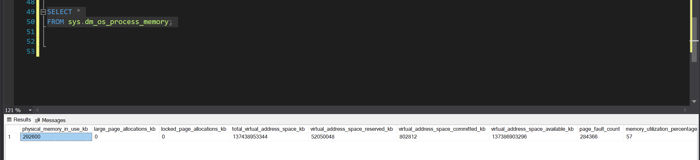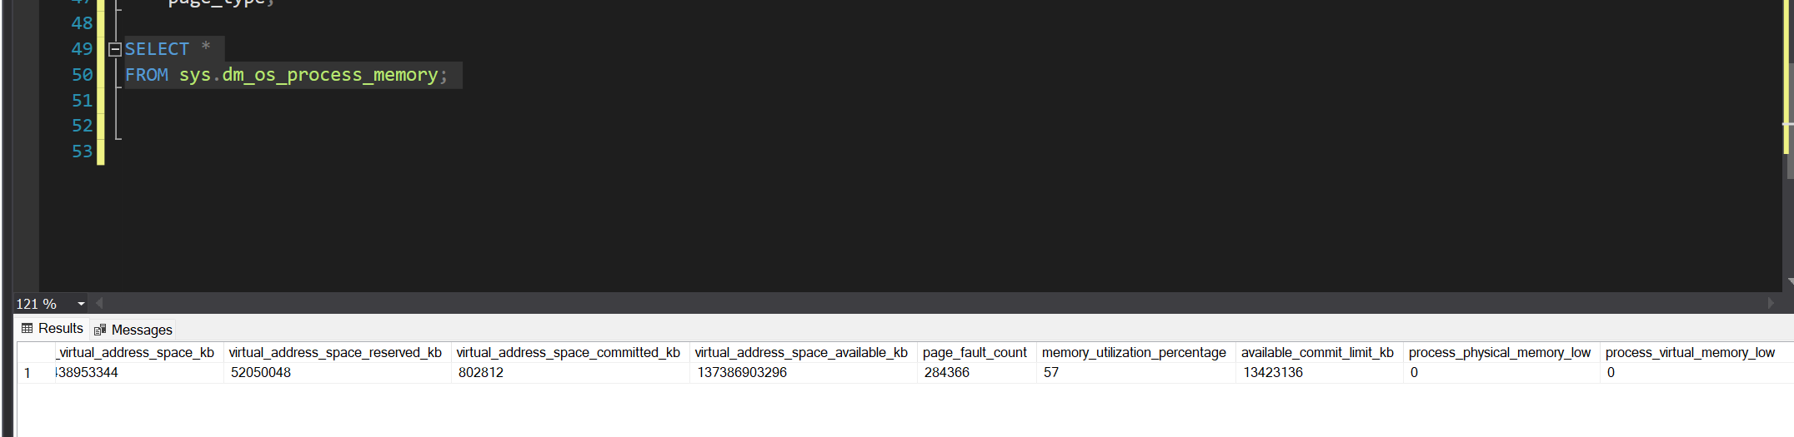

Week 7: Transactions and Concurrency Control
To do this example, let me add myself a user into the database as an example, and add 1 as the my kuota.
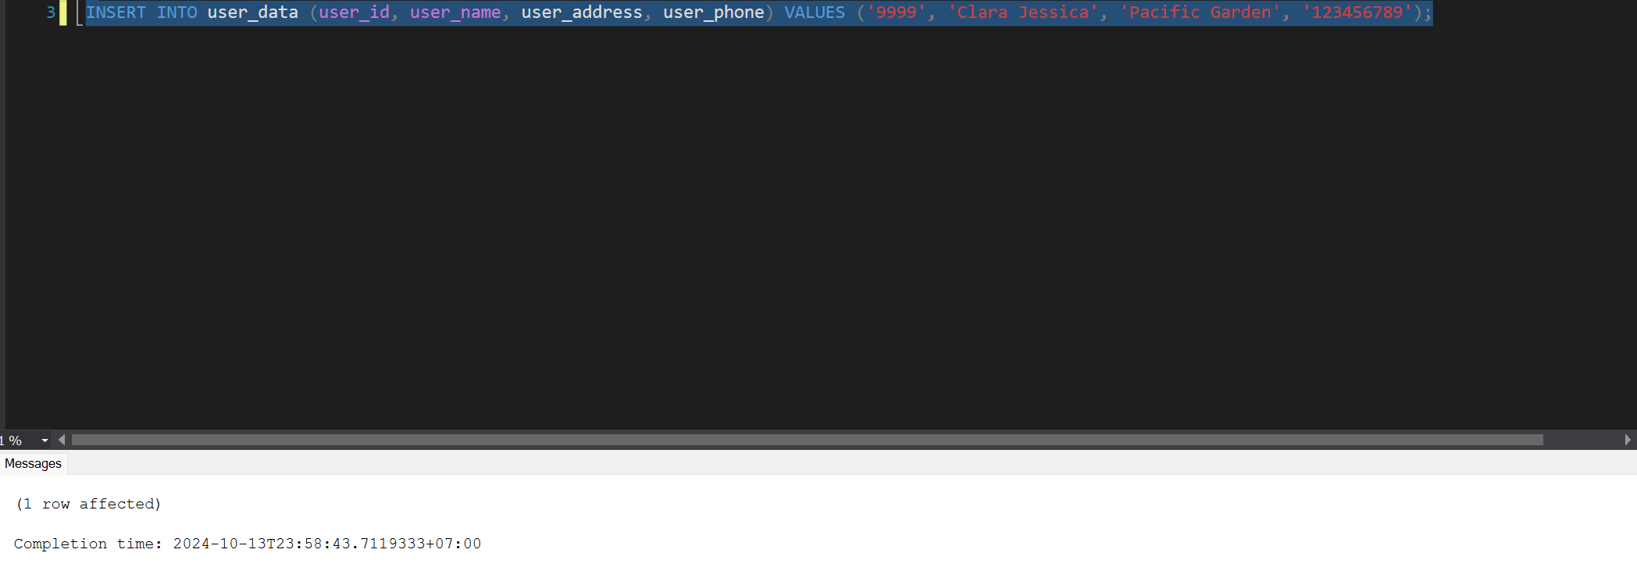
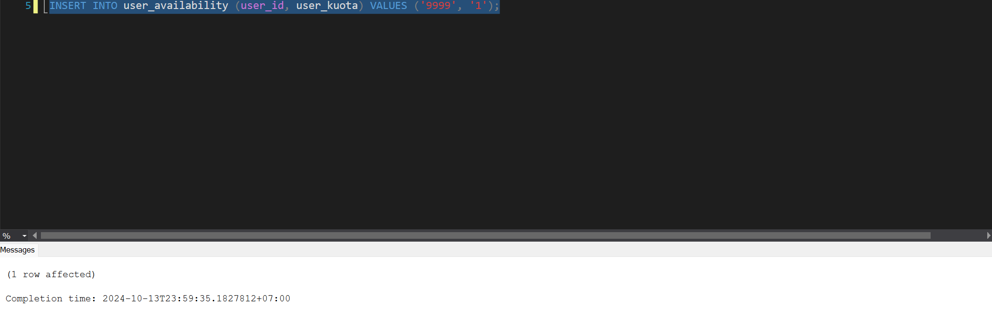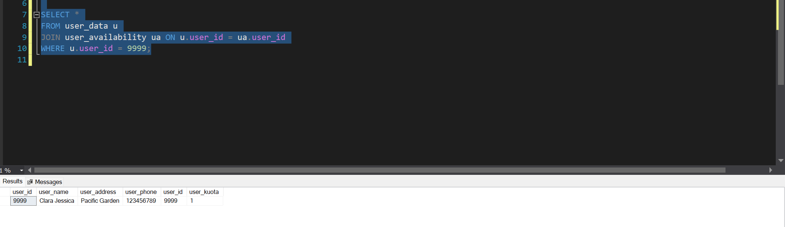

Transaction 1: Borrow a Book
Let us borrow the book Outside modern use, which has a book_id of 2331.
- Check if the book is available for borrowing (ensure stock > 0).
So let me check if the stock is available
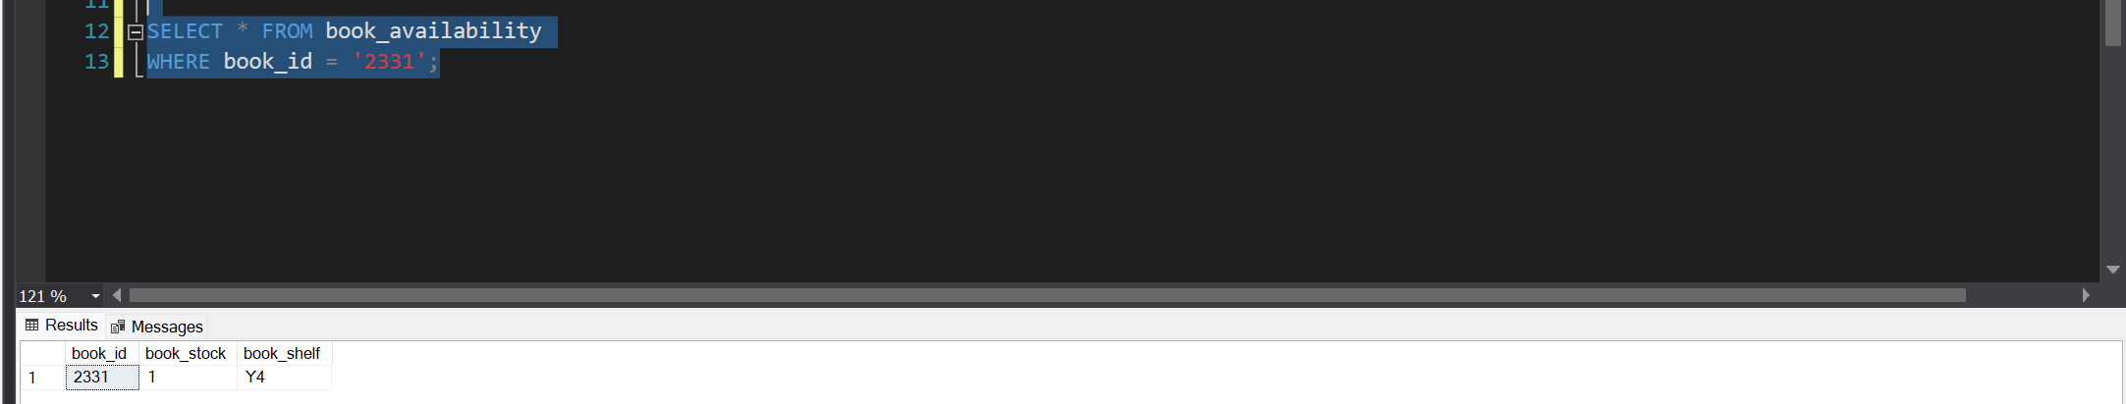
So the book is available, and it is the last one.

- If available, update the loan table to add the new loan.
So let’s add the borrowing data to the reserve_borrow table, let’s assume that the maximum time that they borrow is 2 months.
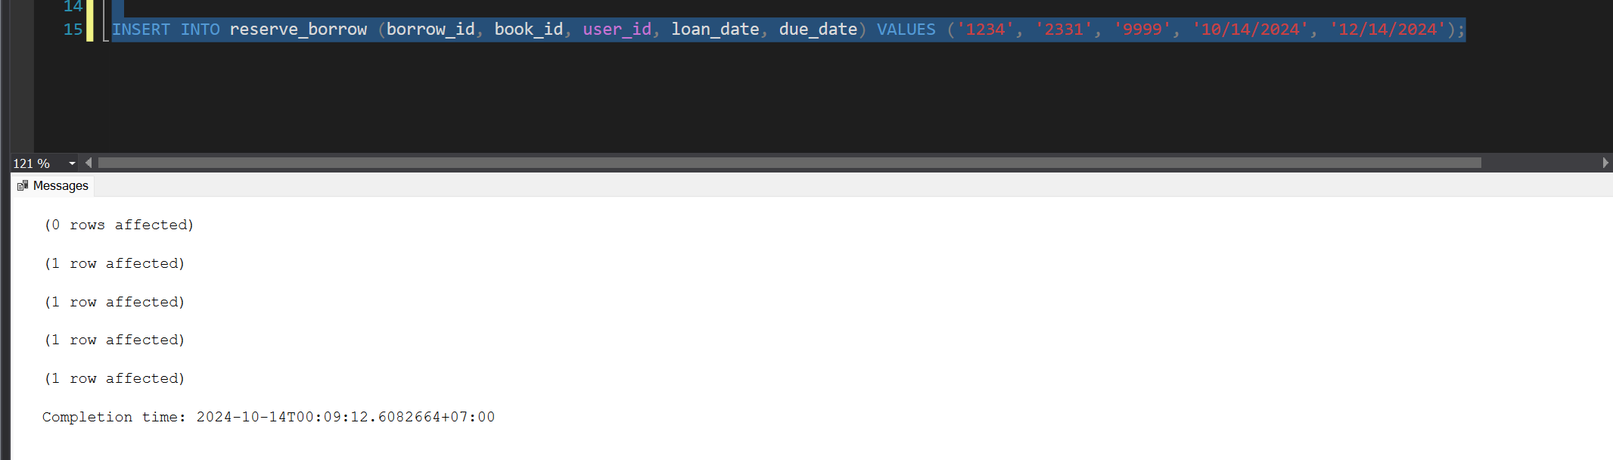
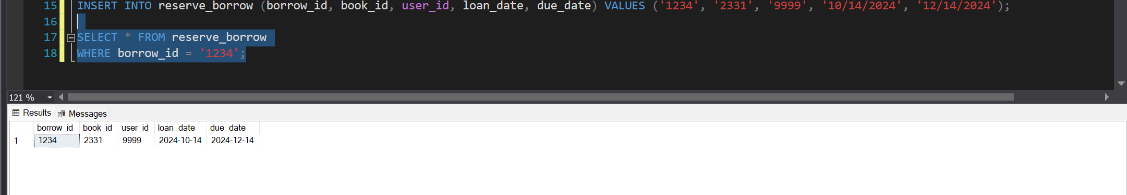
We have successfully added the data into the reserve_borrow table

- Decrease the book's stock count by 1.
We don’t need to do this manually, as I have made a trigger that automatically decreases the book_stock and user_kuota, I will elaborate more on week 9.
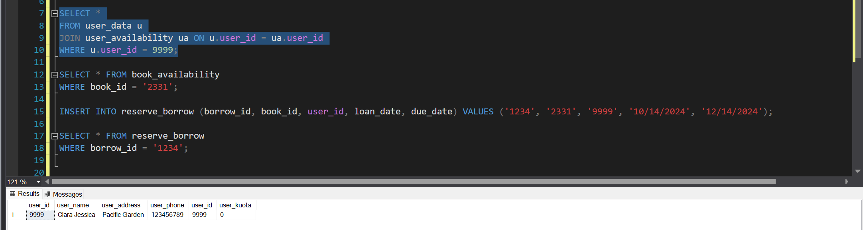
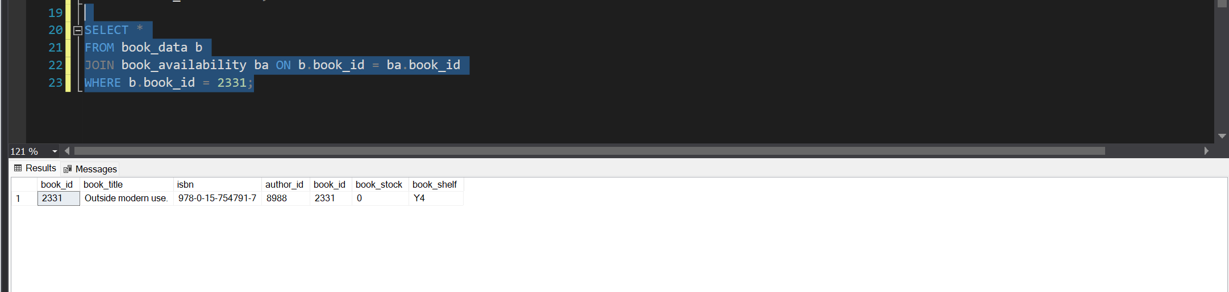

- If any of these steps fail (e.g., the book is already loaned out or stock is insufficient), the entire transaction should roll back.
So now, my kuota is 0

If I wanted to borrow a book, I would not be able to.

Transaction 2: Return a Book
So now let me return the book
- Check if the book was loaned out to the user.
Here I am checking which book the user borrowed
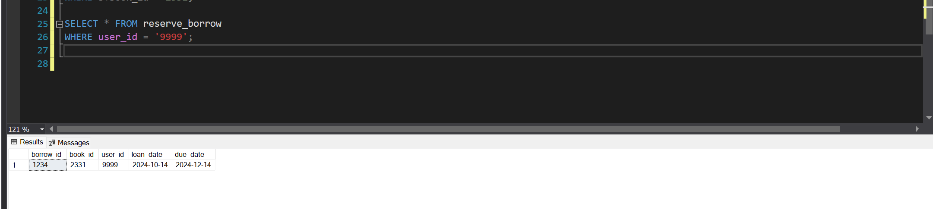
After knowing which book has been borrowed, I will now start the return process
- Update the loan table to mark the book as returned.
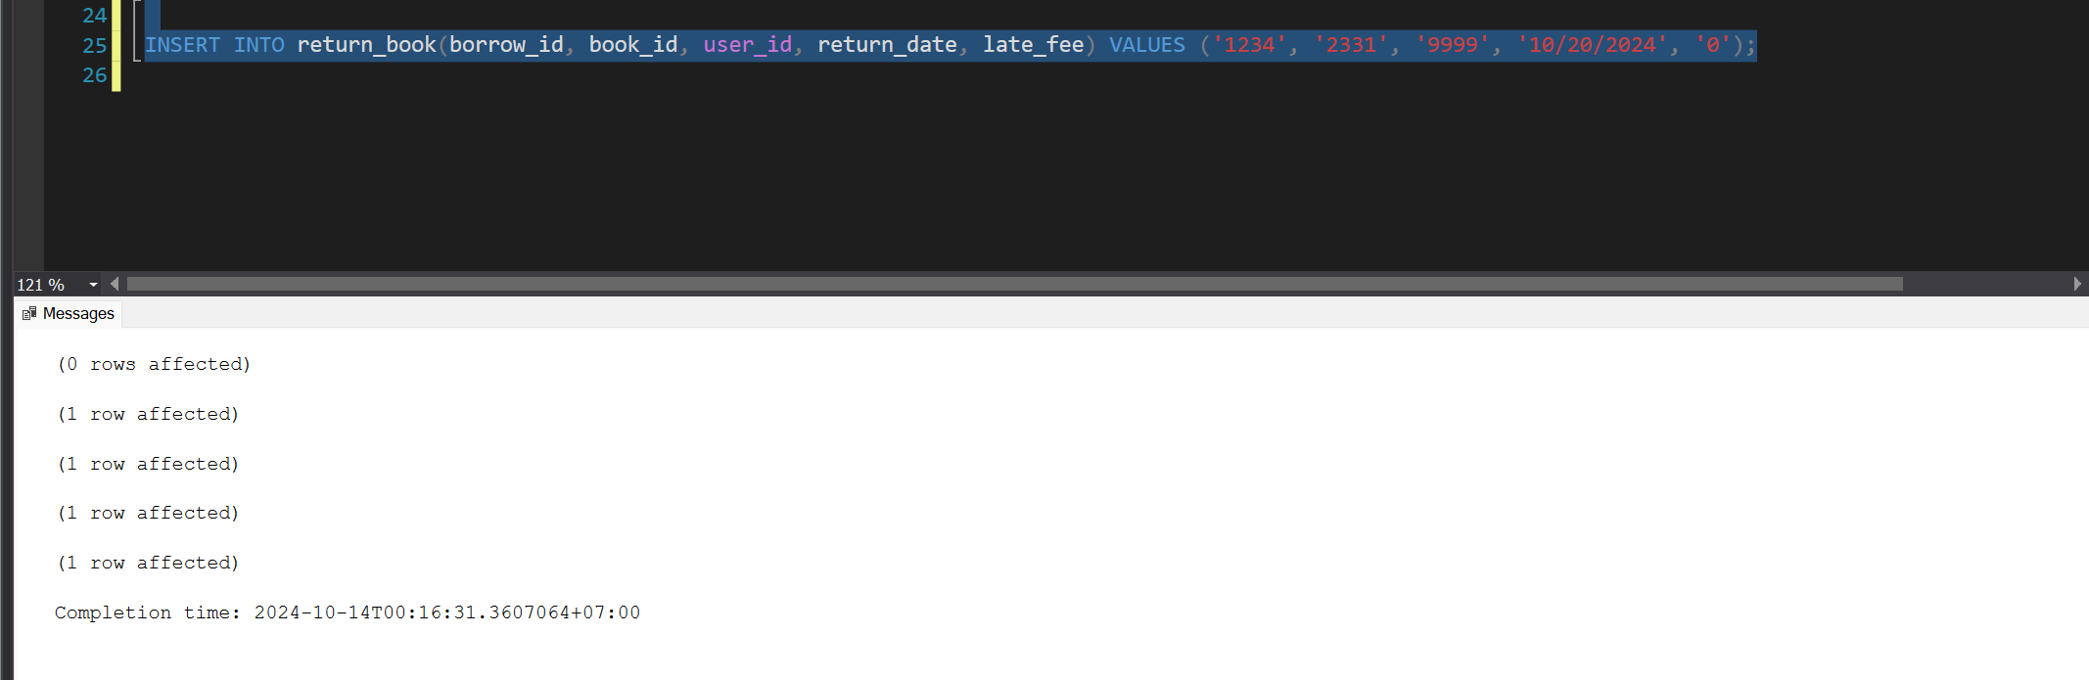
I have successfully entered into the return_book table

- Increase the book's stock count by 1.
Again, as I said before, I don’t need to do this manually, as I have made a trigger that automatically increases the book_stock and user_kuota, which I will elaborate more on week 9.
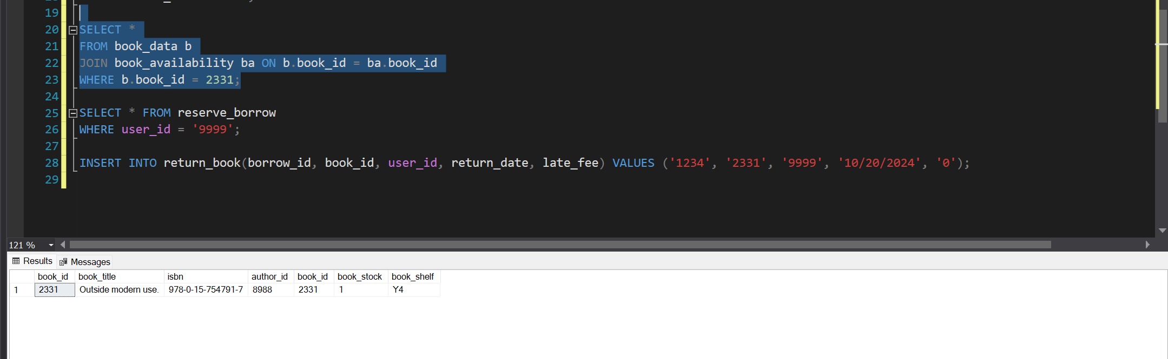
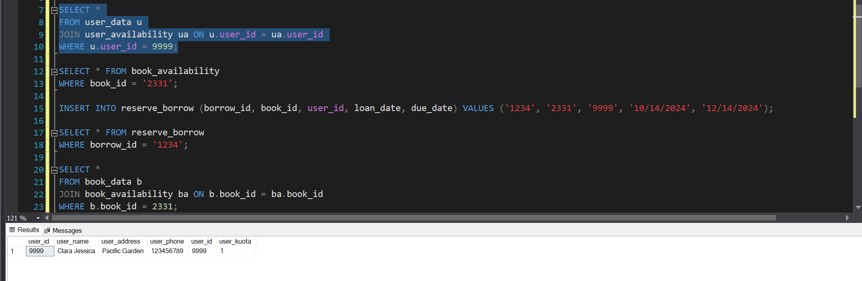

- If the book wasn't actually loaned out to the user or another issue occurs, the transaction should roll back.
This is what will happen if the user is not returning the right book
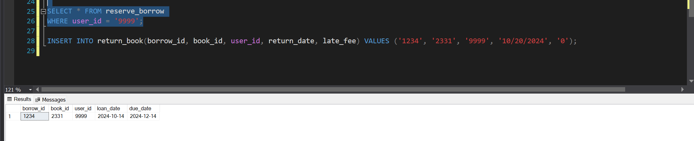
Here the book that is being borrowed has an id of 2331, if the user were to return a book, with another id, the return/borrow manager shouldn’t allow it, and should ask the user to bring in the correct book

Transaction 3: Reserve a Book
For example, if I wanted to borrow the book Before ever. which has the book_id of 5731
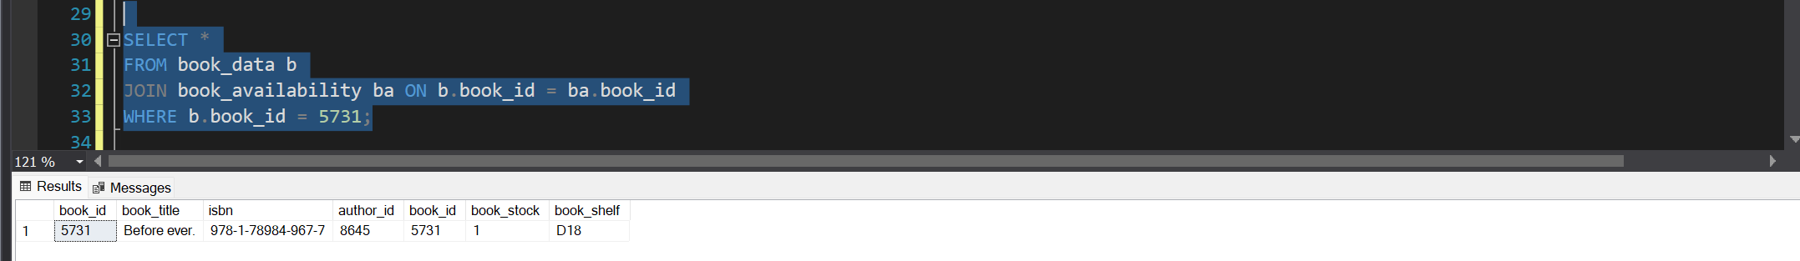
This still has a stock of 1, so let me first make another user borrow it

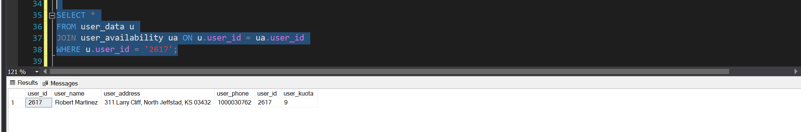
Robert still has a kuota of 9, so let me make him borrow the book 1st

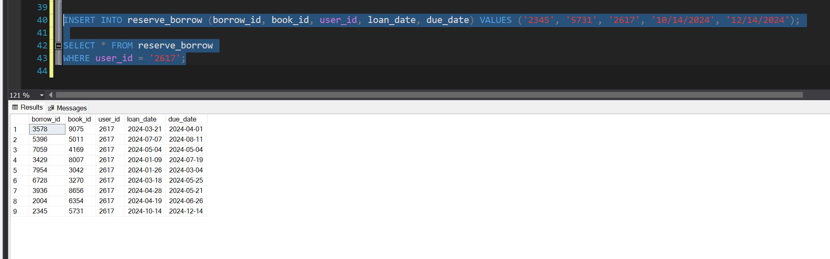
Now that that is done, the stock should be 0

- Check if the book is currently unavailable (i.e., all copies are loaned out).
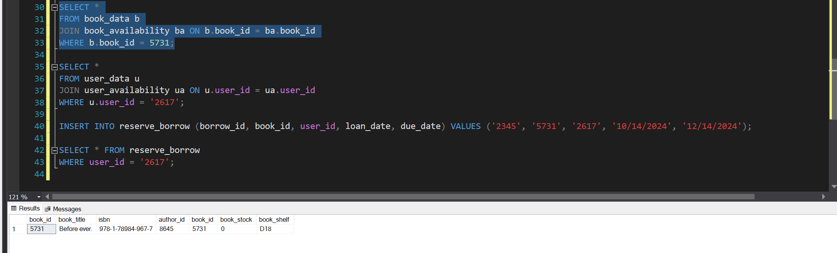
The book is indeed out of stock

- Insert a reservation into the reservations table for the user.
So as I have combined the reserve and borrow table into 1, I will just enter it in the same table and enter the loan date as the date the book should be due from the previous borrower
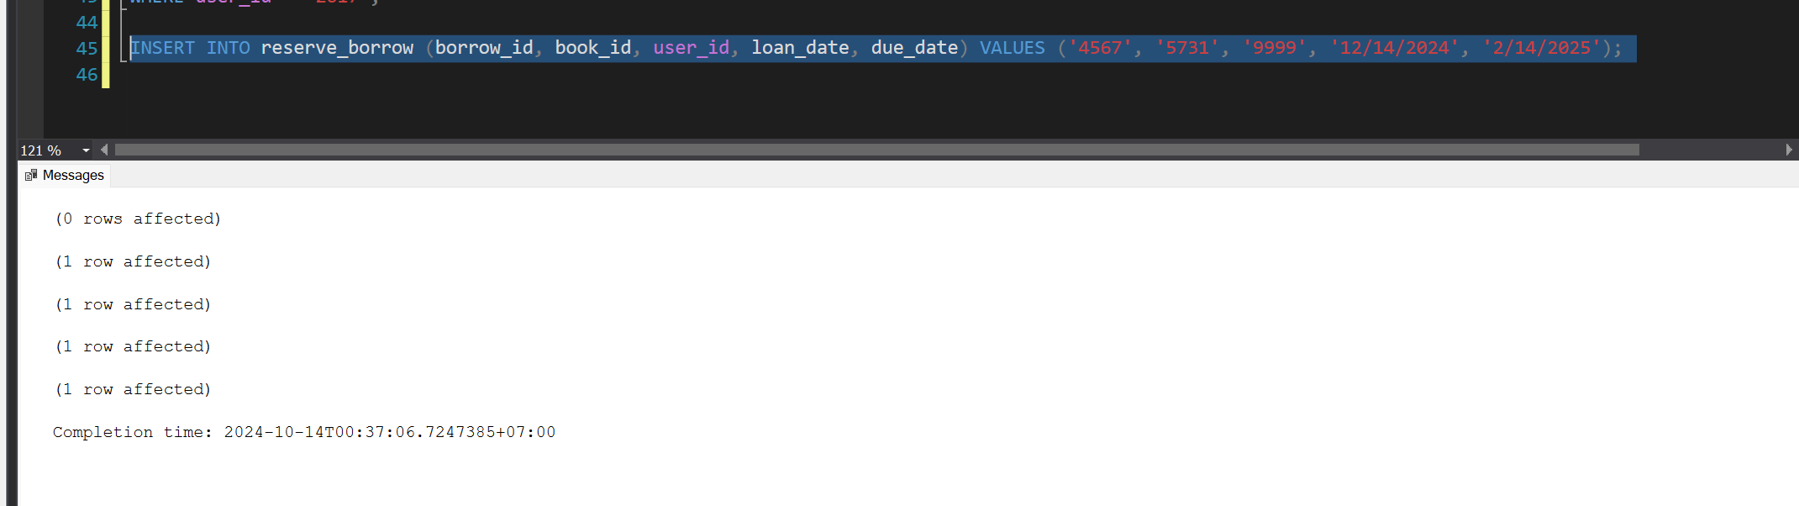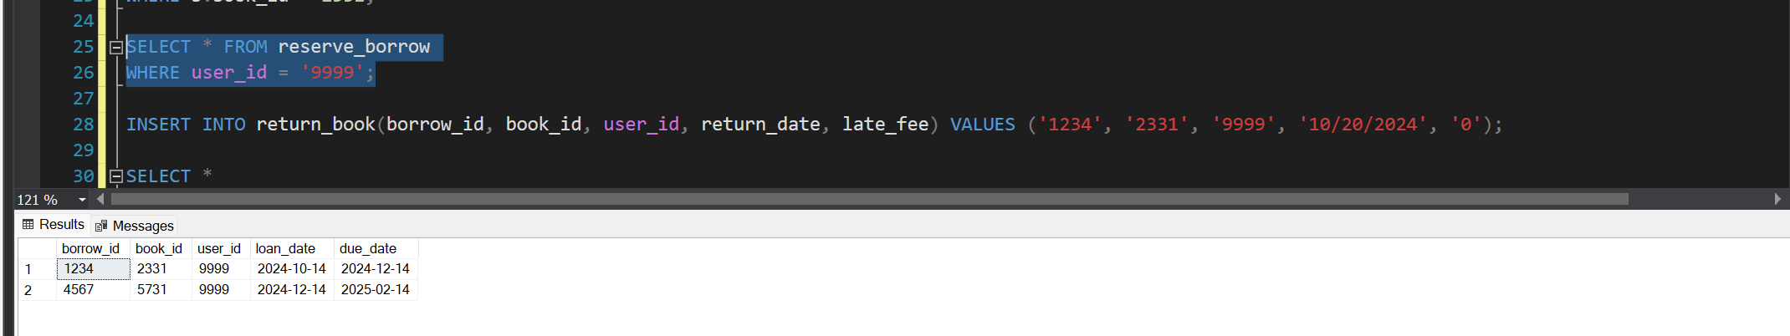
So now we have created a reservation, to signify that it is a reservation, its loan_date should still be in the future

- If the book becomes available during the transaction, roll back the reservation process.
If before the designated loan_date the book is returned, the reserve/borrow manager will inform the borrower.

Transaction 4: Add a New Book to the Library
Before adding a new book, we must first add an author, for example if I wanted to add the book After by Anna Tod.
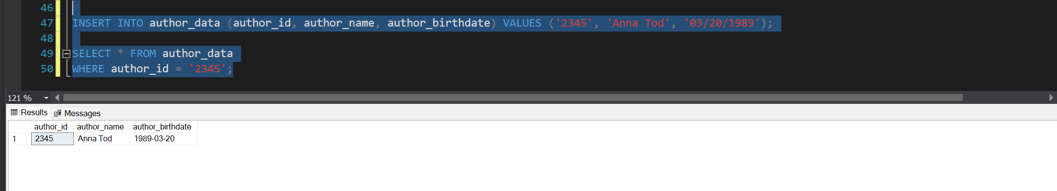
Now we can start adding the book
- Insert the new book's details into the book table (title, author, ISBN, etc.).
Let me start adding the book After by Anna Tod with ISBN 978-3-4534-9116-8
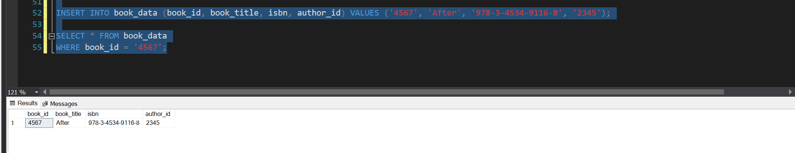
I have now successfully added the book into the book_data table

- Insert the initial stock information (e.g., 5 copies) into the stock table.
Now let me add the book stock which is 5
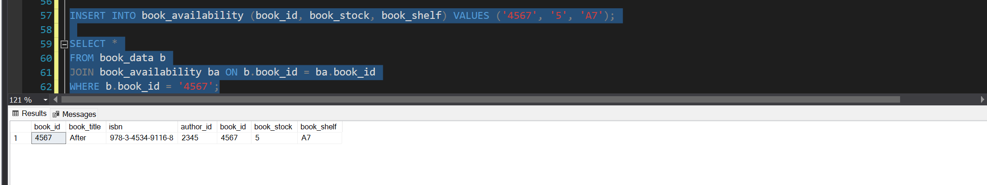
I have now successfully entered the book stock as well as the book shelf

- If there is a failure during the insertion of either the book details or the stock, the transaction should roll back.
If I were to have entered the wrong book_id, this is what would’ve happened.
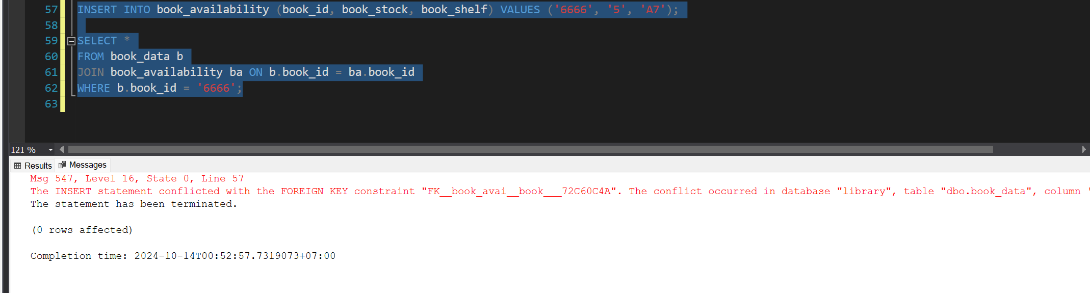

Transaction 5: Delete a User Account
Here I will delete my own account with user_id 9999 as to not mess up the data already set in the database
- Check if the user has any outstanding loans. If yes, the transaction fails and the process is rolled back.
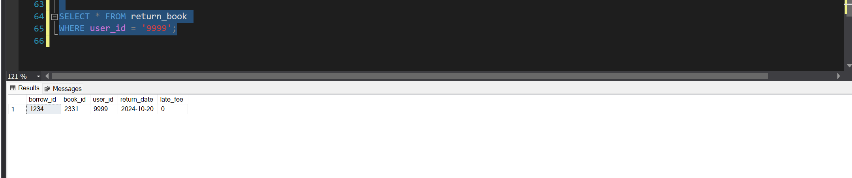
Here the user has 0 late fees, the user also doesn’t have any unreturned books so we should proceed.

- Check if the user has any reservations. If yes, cancel the reservations.
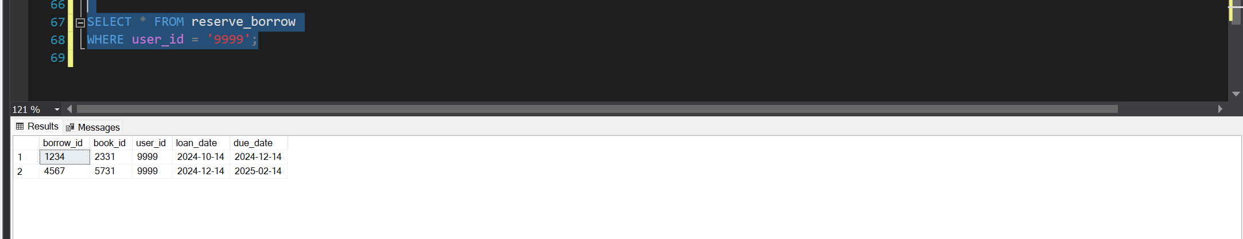
But the user does in fact have a reservation, so let us delete it first.

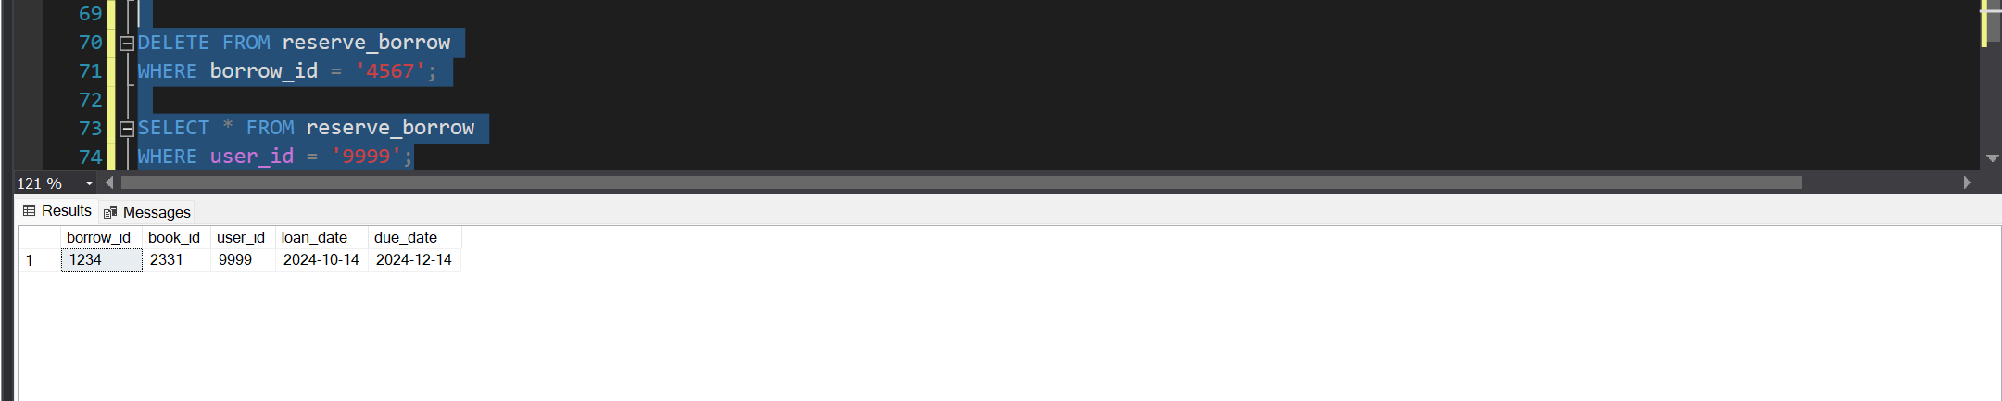
now that we have deleted the reservation, we can proceed

- Delete the user account from the user table.
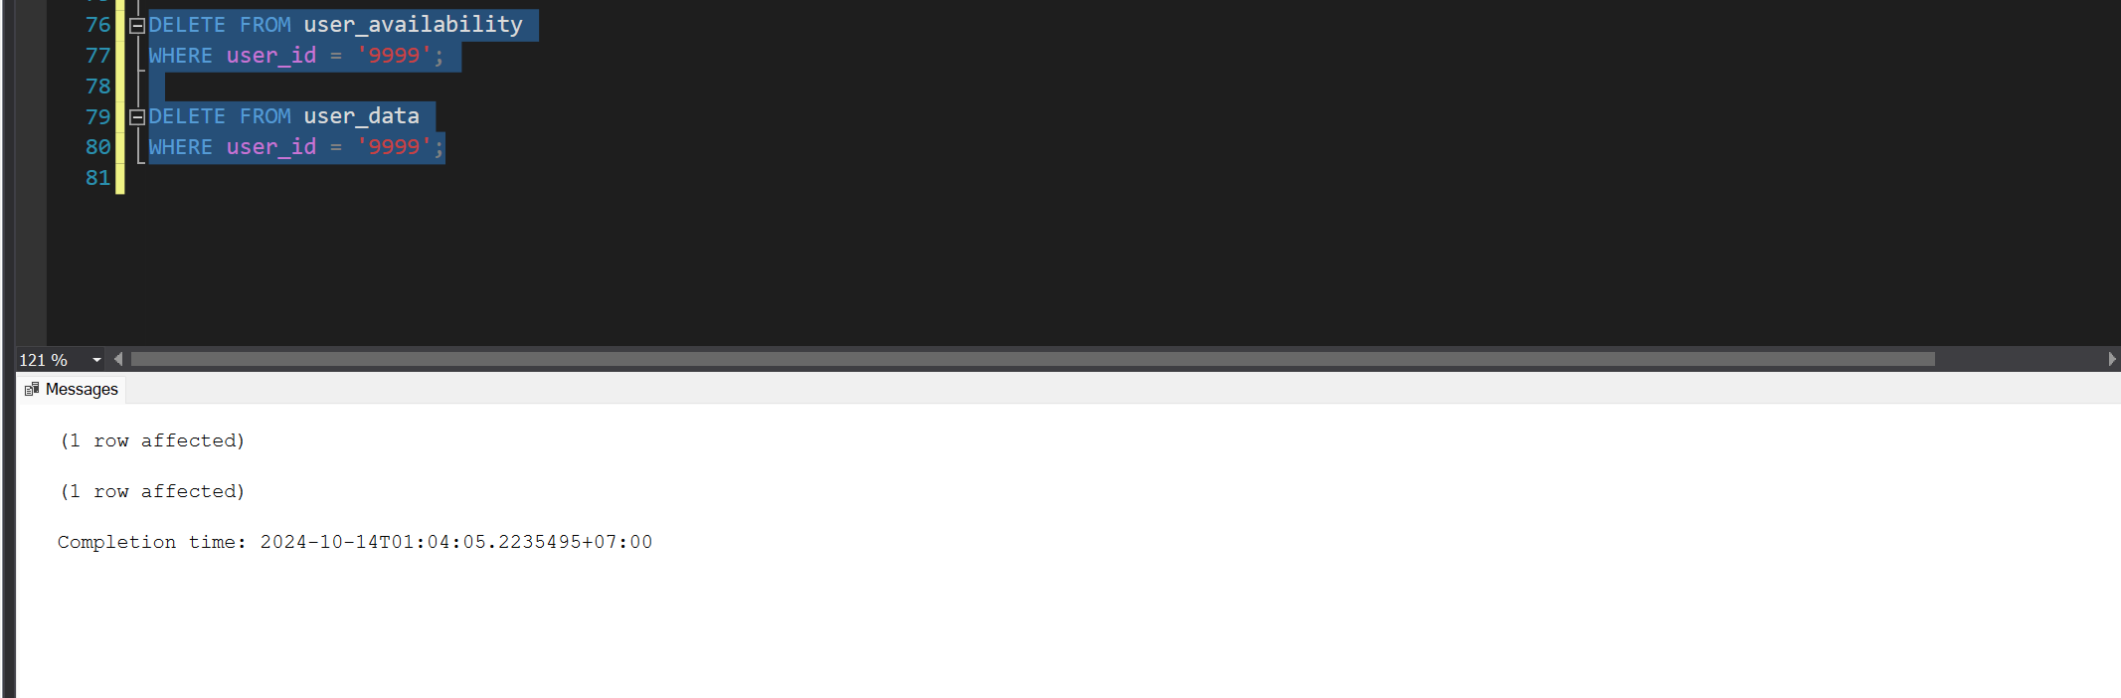
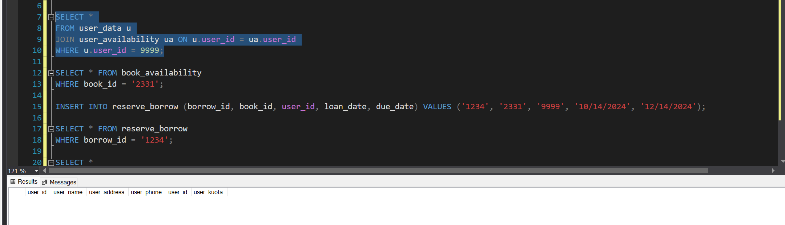
Now we have deleted every aspect of the user from our system
4. If any error occurs, or if the user still has outstanding loans, the entire process should be rolled back.
As the user did not have any outstanding loans, we proceeded with the delete, if they did, the reserve/borrow manager would have to ask them to settle their loan 1st

Week 8: Security and Backup
Here I have made 4 roles, which are: library_librarian, library_user, library_borrow_return_manager, and library_backup_operator.
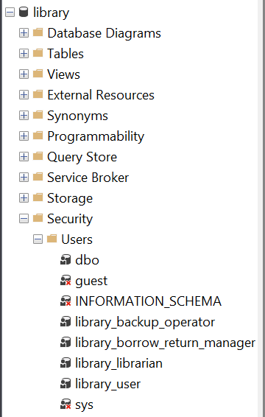
Here are the permissions of each role:
-library_librarian
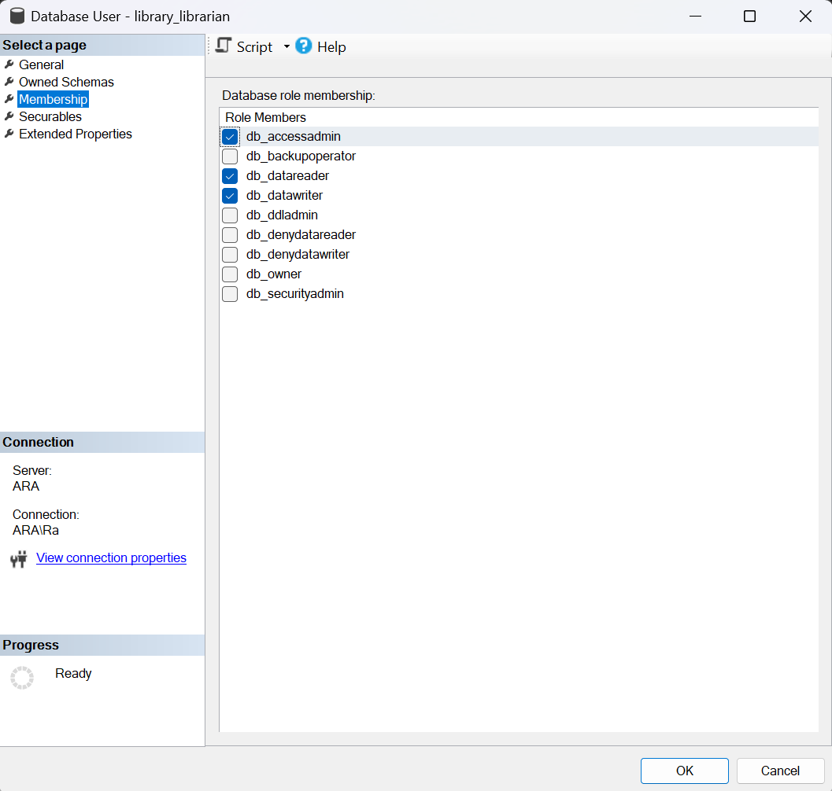
First, db_datareader will allow the librarian to read data from all tables (e.g., viewing books, customers, loans, and return records). Then db_datawriter will allow the librarian to modify the data (e.g., adding or updating book details, managing reservations). Lastly, db_accessadmin can be useful if librarians need to manage access to some database objects, like managing new users or setting restricted access for books.
-library_user
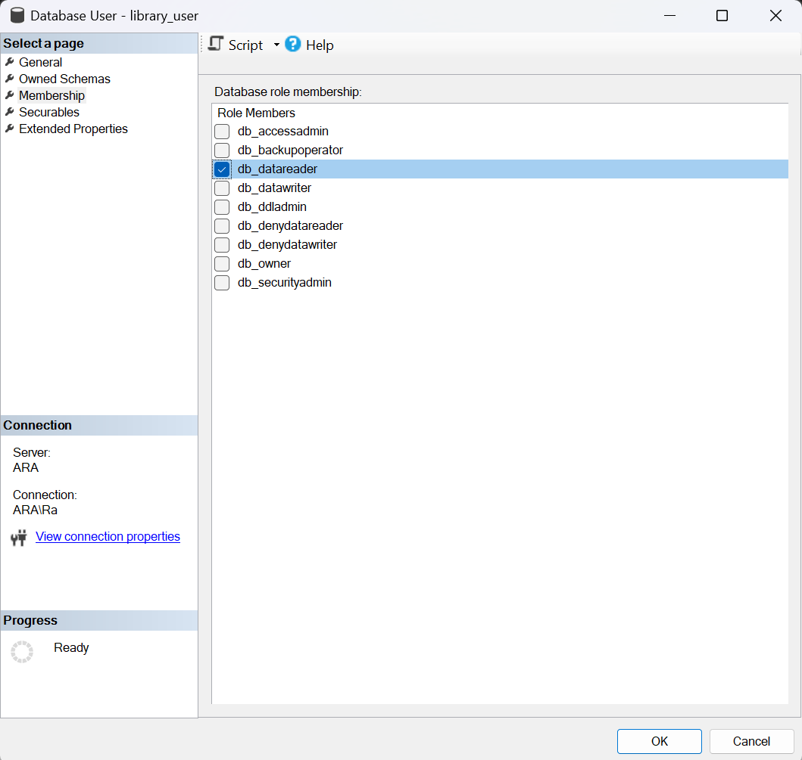
First is db_datareader the user should have read access to the relevant tables. This ensures they can only view available books and their own borrowing records. Custom permissions will be required to restrict access to only certain rows (for example, only their own loan records). But to be honest, I haven’t fully grasped on how to do that with ease, so for now, this is as far as I can do.

- library_borrow_return_manager
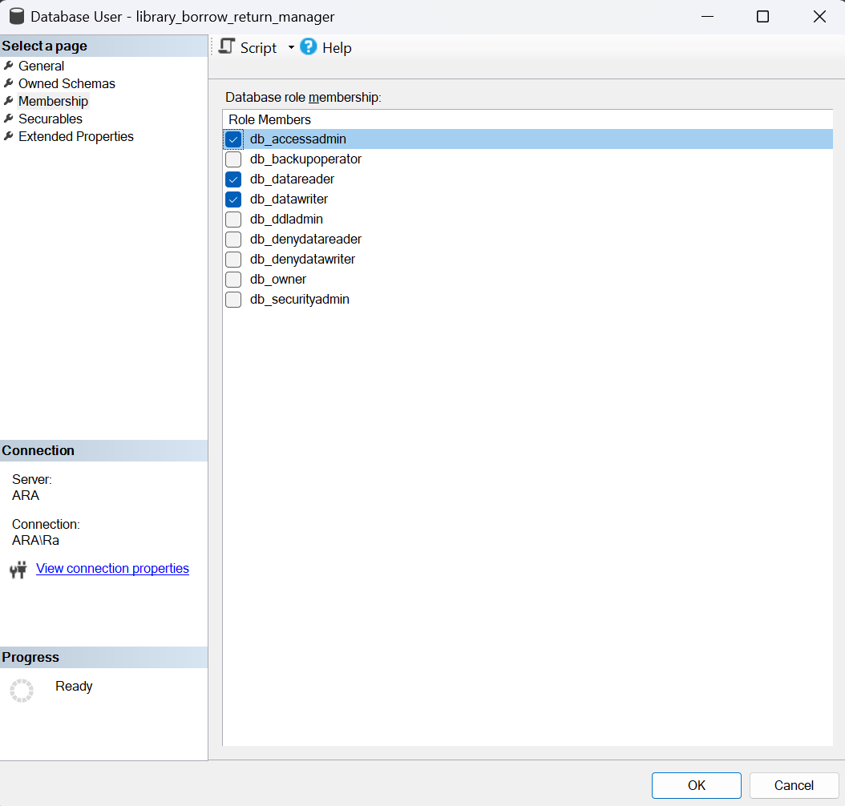
First for the library_borrow_return_manager is db_datareader the borrow/return manager needs read access to all loan-related records. Then db_datawriter to handle reservations and returns, the borrow/return manager needs the ability to modify data (e.g., mark a book as borrowed or returned). Lastly, db_accessadmin incase user needs to change their personal details, like their address or phone number.

-library_backup_operator
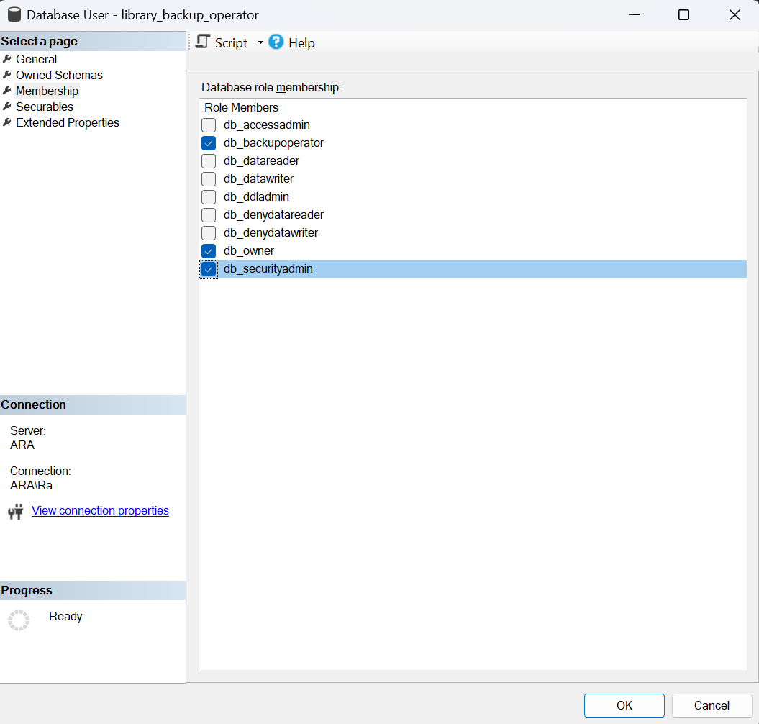
First is db_owner, this will allow full control over the database, allowing the backup operator to do any administrative and management tasks that they need to do. Then we have db_securityadmin which allows the backup operator to manage roles, permissions, and database security. Lastly, db_backupoperator this allows the backup operator to manages backups for the library database.

Week 9: Advanced Features

TRIGGERS:
-reduce_user_quota_and_book_stock_trigger
GO
CREATE TRIGGER reduce_user_quota_and_book_stock_trigger
ON reserve_borrow
AFTER INSERT
AS
BEGIN
UPDATE ua
SET ua.user_kuota = ua.user_kuota - 1
FROM user_availability ua
INNER JOIN inserted i ON ua.user_id = i.user_id;

UPDATE ba
SET ba.book_stock = ba.book_stock - 1
FROM book_availability ba
INNER JOIN inserted i ON ba.book_id = i.book_id;
END;
GO

This trigger is called reduce_user_quota_and_book_stock_trigger and it will automatically run when a data is inserted into the reserve_borrow table, it will then update the user_availability table and reduce user_kuota as well the book_availability table and reduce the book_stock, it will reduce it by 1 from each respective table.

PROOF: 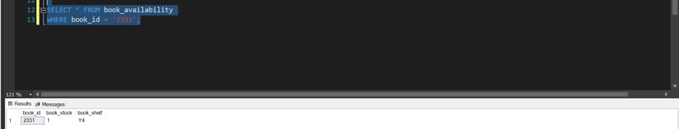





-increase_user_quota_and_book_stock_trigger
GO
CREATE TRIGGER increase_user_quota_and_book_stock_trigger
ON return_book
AFTER INSERT
AS
BEGIN
UPDATE ua
SET ua.user_kuota = ua.user_kuota + 1
FROM user_availability ua
INNER JOIN inserted i ON ua.user_id = i.user_id;

UPDATE ba
SET ba.book_stock = ba.book_stock + 1
FROM book_availability ba
INNER JOIN inserted i ON ba.book_id = i.book_id;
END;
GO

This trigger is called increase_user_quota_and_book_stock_trigger and it will automatically run when a data is inserted into the return_boook table, it will then update the user_availability table and increase user_kuota as well the book_availability table and increase the book_stock, it will increase it by 1 from each respective table.

PROOF:





COMPLEX QUERIES:

-EXAMPLE 1:
If we wanted to find all the borrow history of the user that is from the company DDS
SELECT rb.*
FROM reserve_borrow rb
JOIN user_data ud ON rb.user_id = ud.user_id
WHERE ud.user_name LIKE '%DDS%';

This code would select all data from the reserve borrow table, and join with the user data table to find the user_id which has ‘DDS’ in their name, and use the user_id found to display all their borrowing data
Result:
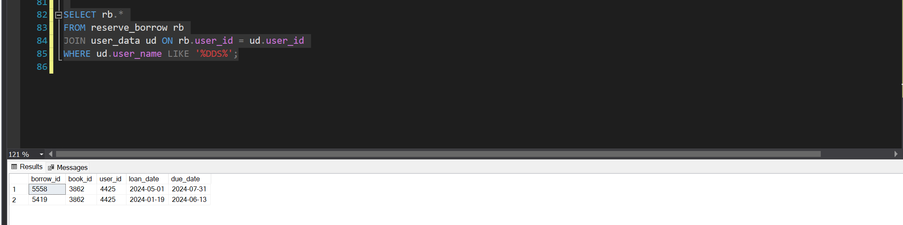

-EXAMPLE 2:
If we wanted to find all the borrow history of the books borrowed by users who have ‘New’ in their address
SELECT rb.*
FROM reserve_borrow rb
JOIN user_data ud ON rb.user_id = ud.user_id
WHERE ud.user_address LIKE '%New%';

This code would select all data from the reserve borrow table, and join with the user data table to find the user_id which has ‘New’ in their address, and use the user_id found to display all their borrowing data
Result:
